  - 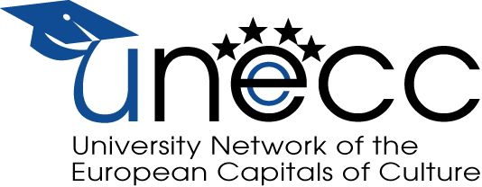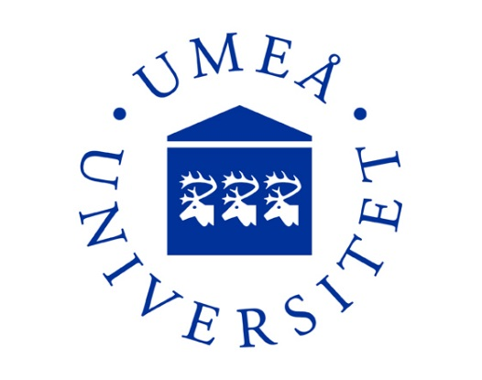

Eighth INTERDISCIPLINARY CONFERENCE
of the
UNIVERSITY NETWORK of the EUROPEAN CAPITALS of CULTURE
CULTURE AND GROWTH –
MAGICAL COMPANIONS OR MUTUALLY EXCLUSIVE COUNTERPARTS?
23-24 October 2014
hosted by Umeå University

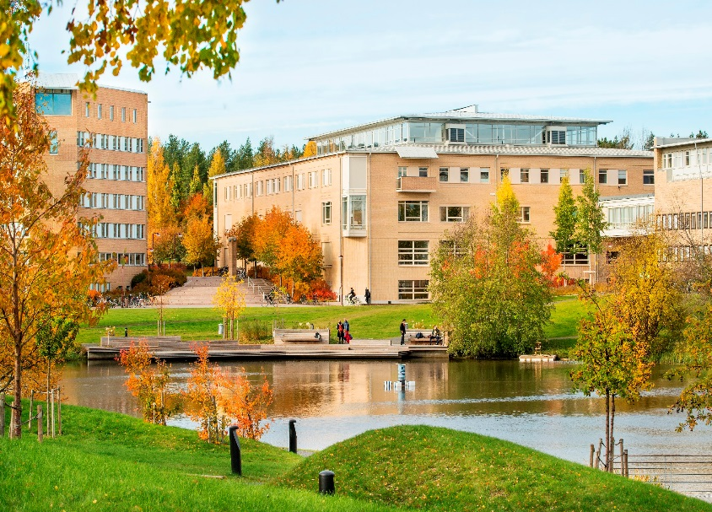

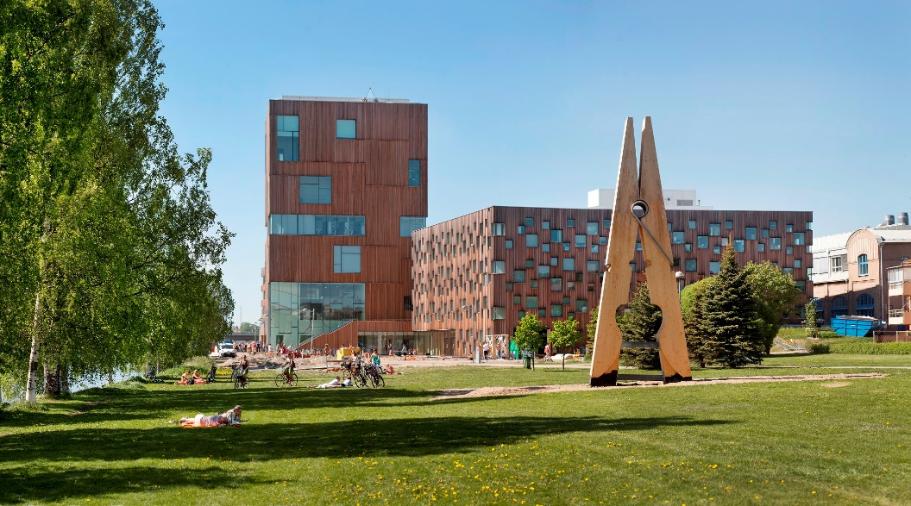

Thursday October 23, 2014
Venue: Bildmuseet, Flexhallen. (Arts Campus).

09.00 - 10.00 Registration. Coffee and sandwiches.
(09.15 – 09.45 Press conference)
10.00 - 12.00 Opening session
Prof. Flora Carrijn, President UNeECC
Prof. Lena Gustafsson, Vice-Chancellor at Umeå University
Marie-Louise Rönnmark, Mayor of Umeå
Fredrik Lindegren, Artistic Director, Umeå 2014
Katarina Pierre, Director Bildmuseet, Umeå University
Karl-Erik Norrman, Ambassador, Secretary General of the European Cultural Parliament: Europe and the Age of Culture.
12.15 - 13.15 Keynote lecture
Franco Bianchini. Professor of Cultural Policy and Planning at Leeds Beckett University, UK: Participation, citizenship and growth as issues in contemporary European urban cultural strategies
13.15 - 14.15 Buffet lunch
14.15 – 15.15 General Assembly
15.15-15.30 Coffee break
15.30 – 16.50 Parallel sessions I
Session A: Culture, Sustainability, and Wellbeing  Venue: Bildmuseet, Flexhallen  Chair: Britta Lundgren | Session B: Co-creating Culture  Venue: Sliperiet  Chair: Katrin Holmqvist-Sten
Nataša Urošević, University of Pula, Croatia:  Culture and sustainable urban development – valuing a common European heritage in Croatian candidates for the ECoC | Nadia Carboni, Ravenna 2010 ECoC candidate city office, Municipality of Ravenna, Italy:  Becoming European Capital of Culture in the 21st century: challenges and opportunities for both culture and growth
Joanna Sanetra-Szeliga, Krakow University of Economics, Poland:  Culture as a vital element of the quality of life improvement. ECoC 2016 strategies and their legacy in Poland. | Malin Näsholm, Umeå University, Umeå, Sweden:  The meaning of co-creation of culture.
Christine Hudson, Linda Sandberg and Ulrika Schmauch, Umeå University, Sweden:  Uniting or dividing? Exploring culture´s role in the search for the just city. | Anera Stopfer, Ministry of Culture, Croatia:  Croatian local authorities in the process of Co-creating culture throughout ECOC bidding process
Szilvia Nagy, Eötvös Loránd University, Budapest, Hungary:  After effects: Local community involvement and sustainability in the European Capitals of Culture program in Central and Eastern Europé | Katalin Füzér, University of Pécs, Hungary.  Probing participatory urban development: ECoC and urban strategies in post-millenial Pécs
19.30 Dinner at Rex Restaurant, Rådhuset 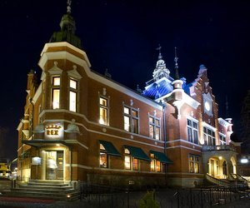
Friday, October 24, 2014
Venue: Naturvetarhuset, Umeå University
08.30 - 09.50 Parallel sessions II
Session C: Culture and identities (1)  Venue: Naturvetarhuset, N 420  Chair: Rolf Hugoson | Session D: Culture and growth: Theories and methodologies (1)  Venue: Naturvetarhuset, N 320  Chair: Nils Wåhlin
Witold Ostafínski, the Pontifical University of John Paul II in Cracow, Poland:  Cultural assimilation vs. Cultural pluralism. The problems of contemporary Europe. | Morten Falbe-Hansen, Central Denmark Region/Aarhus 2017:  Dealing with regional assumptions behind culture-driven growth.
Annette Löf, Umeå University, Umeå, Sweden:  Cultural colonisation or arena for participation and self-determination? Analysing the Capital of Culture year in Umeå based on a Sami rights perspective. | Daniela Preda and Eva-Nicoleta Burdusel, ”Lucian Blaga” University of Sibiu:  University community – Collaboration for cultural sustainability and economic growth.  .
Anne Heith, Umeå University, Umeå, Sweden:  Minorities, cultural transformations and rethinking the nation: Performative aspects of Sámi elements in Umeå 2014. | Lars Westin, Umeå University, Umeå, Sweden:  Mobilization of the cultural assets of a city.
Daniella Wikerman, Malmö University, Sweden:  European Culture in the Umeå 2014 programme. | Maxime Jaffré, Elena Raevskikh, and Emmanuel Pedler, École des Hautes Études en Sciences Social – Centre Norbert Elias (CNE), Marseille, France:  The reorganization and renewal of cultural institutions in the European Cultural Capitals´ landscape.

9.50-10.20 Coffee break

10.20-11.40 Parallel sessions III
Session E: Culture and identities (2)  Venue: Naturvetarhuset, N 420  Chair: Eva-Nicoleta Burdusel | Session F: Culture and growth: Theories and methodologies (2)  Venue: Naturvetarhuset, N 320  Chair: Lars Westin
Cyril Fegué, University of Luxembourg & HIS (International Institute of Urban Management) Erasmus University, Rotterdam.  Culture-driven urban growth management: Pushing forward the Devolution-sensitive Co-creation agenda – insights from Mali in West-Africa | Andrei Terian, Lucian Blaga University, Sibiu, Romania:  The rise of the Romanian novel: Culture, growth and national identity.
Rolf Hugoson, Umeå University, Umeå, Sweden:  European Capitals of Culture and the new paradiplomacy. | Simina Terian, Lucian Blaga University, Sibiu, Romania:  Romanian capitals of culture: A linguistic analysis.
Natalia Zbroja and Kamilla Kamińska, Wroclaw 2016, Poland: Towards emancipation via culture: micro funding and participatory practices in Capitals of Culture Programmes, based on Wroclaw 2016 example – Microgrants Program | Raquel Luna, University of Luxembourg:  Culture and growth: What is their relation? A historical and philosopical critic to neoclassical economic theory and advances and weaknesses of North´s new institutional economics.
Nils Wåhlin, Umeå university, Umeå, Sweden:
Projective cities: Culture as camera or engine?

11.40 -13.30 Lunch including Culture on Campus: ÁRA

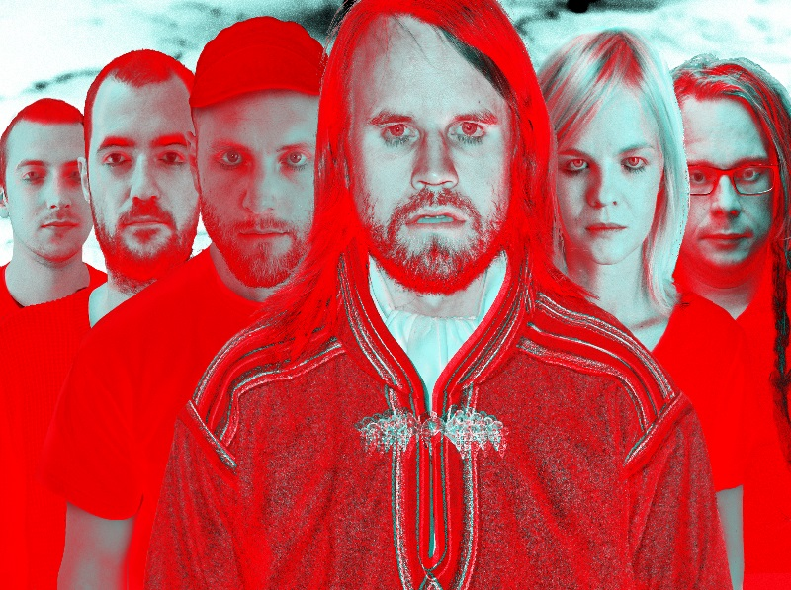

ÁRA exists in the crossroads between the Sámi tradition and the visionary energy. Since their debut, they have created new paths for jojk singing as an art form and aim to bridge national and cultural boundaries.
Friday 24 October, 12.10-12.40 Ljusgården Lärarhuset. Bring your lunchbox and enjoy the music together with students and staff!

13.30 -15.10 Parallel sessions IV
Session G: Culture, space and place  Venue: Naturvetarhuset, N 420  Chair: László Kómlosi | Session H: Culture and growth: Theories and methodologies (3)  Venue: Naturvetarhuset N 320  Chair: Bill Chambers
Roberto Carella and Giuseppe Colucci, University of Basilicata, Matera, Italy:  Movie induced tourism and the competitiveness of tourist destinations, the case study of Matera a candidate European Capital of Culture 2019. | Ana Dadić, University of Zagreb, Croatia:  The use of new technologies in creating an interactive map.
Ovidia Matiu, Lucian Blaga University, Sibiu, Romania:  Culture and identity in Junot Diaz’s ”The Brief Wondrous Life of Oscar Wao”, or The role of art in shaping identities | Louise Ejgod Hansen and Hans-Peter Degn, Aarhus University, Aarhus, Denmark:  How to create an inclusive process as a part of a formative evaluation.
Marta Šlehoferová, University of West Bohemia, Pilsen, Czech Republic:  Development of culture facilities in Pilsen (ECoC 2015): expectations vs. reality | Hans-Peter Degn and Louise Ejgod Hansen, Aarhus University, Aarhus, Denmark:  Designing a research-based evaluation: methods, indicators, target groups
Ineta Luka, Turiba University, Latvia:  Riga – a developing creative tourism destination | Anca Tomuș, Lucian Blaga University of Sibiu, Romania: The Impact of Gentrification on Multicultural/Multi-ethnic Communities: Recent Theoretical Debates and Fictional Representations
Katrin Sten, Umeå University, Umeå, Sweden:
Staging the European Capital of Culture – The role of public space in the contemporary city

15.10 - 15.30 Coffee break
15.30 - 16.30 Concluding remarks (chair Bill Chambers), N 320

19.00 Closing dinner at Sävargården, Gammlia
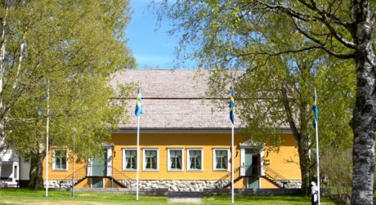

The restaurant Sävargården is situated very close to the Västerbotten County Museum (Västerbottens museum). If you want to visit the museum it will be open from 18.00-20.00 for the conference participants. The museum shop will also be open. http://www.vbm.se/sv/index.html

