Department of Physics 2026-07-30
Umeå University

Project Title
Student name 1
e-mail address
Student name 2
e-mail address

Abstract
What was the aim of the experiment?
What was measured?
Which techniques/methods were used?
What are the main results?
Noninvasive Measurement Techniques
Supervisor(s): name(s)
- Introduction
First paragraph no indent.
Next paragraphs with indent.
Quote references where applicable, e.g. a publication in a scientific journal [1] or a book [2]. Put the reference numbers in the text.
- Theory
Describe all necessary theory.
Number all equations.
Explain all symbols used in the equation. Refer to equations later as Eq. .
Again, quote references where applicable [1, 2].
  - Subsection
Divide into subsections if needed.
Second paragraph.
  - Subsection
Divide into subsections if needed.
Second paragraph.
- Experimental
Describe the experimental setup and procedure.
Next paragraph.
- Results
Describe your results. Use subsections if needed. Include the error analysis.
Place figures close to where you refer to them in the text, e.g. Fig. 1 shows… Format the figures (size) so that there is no empty space on any page.
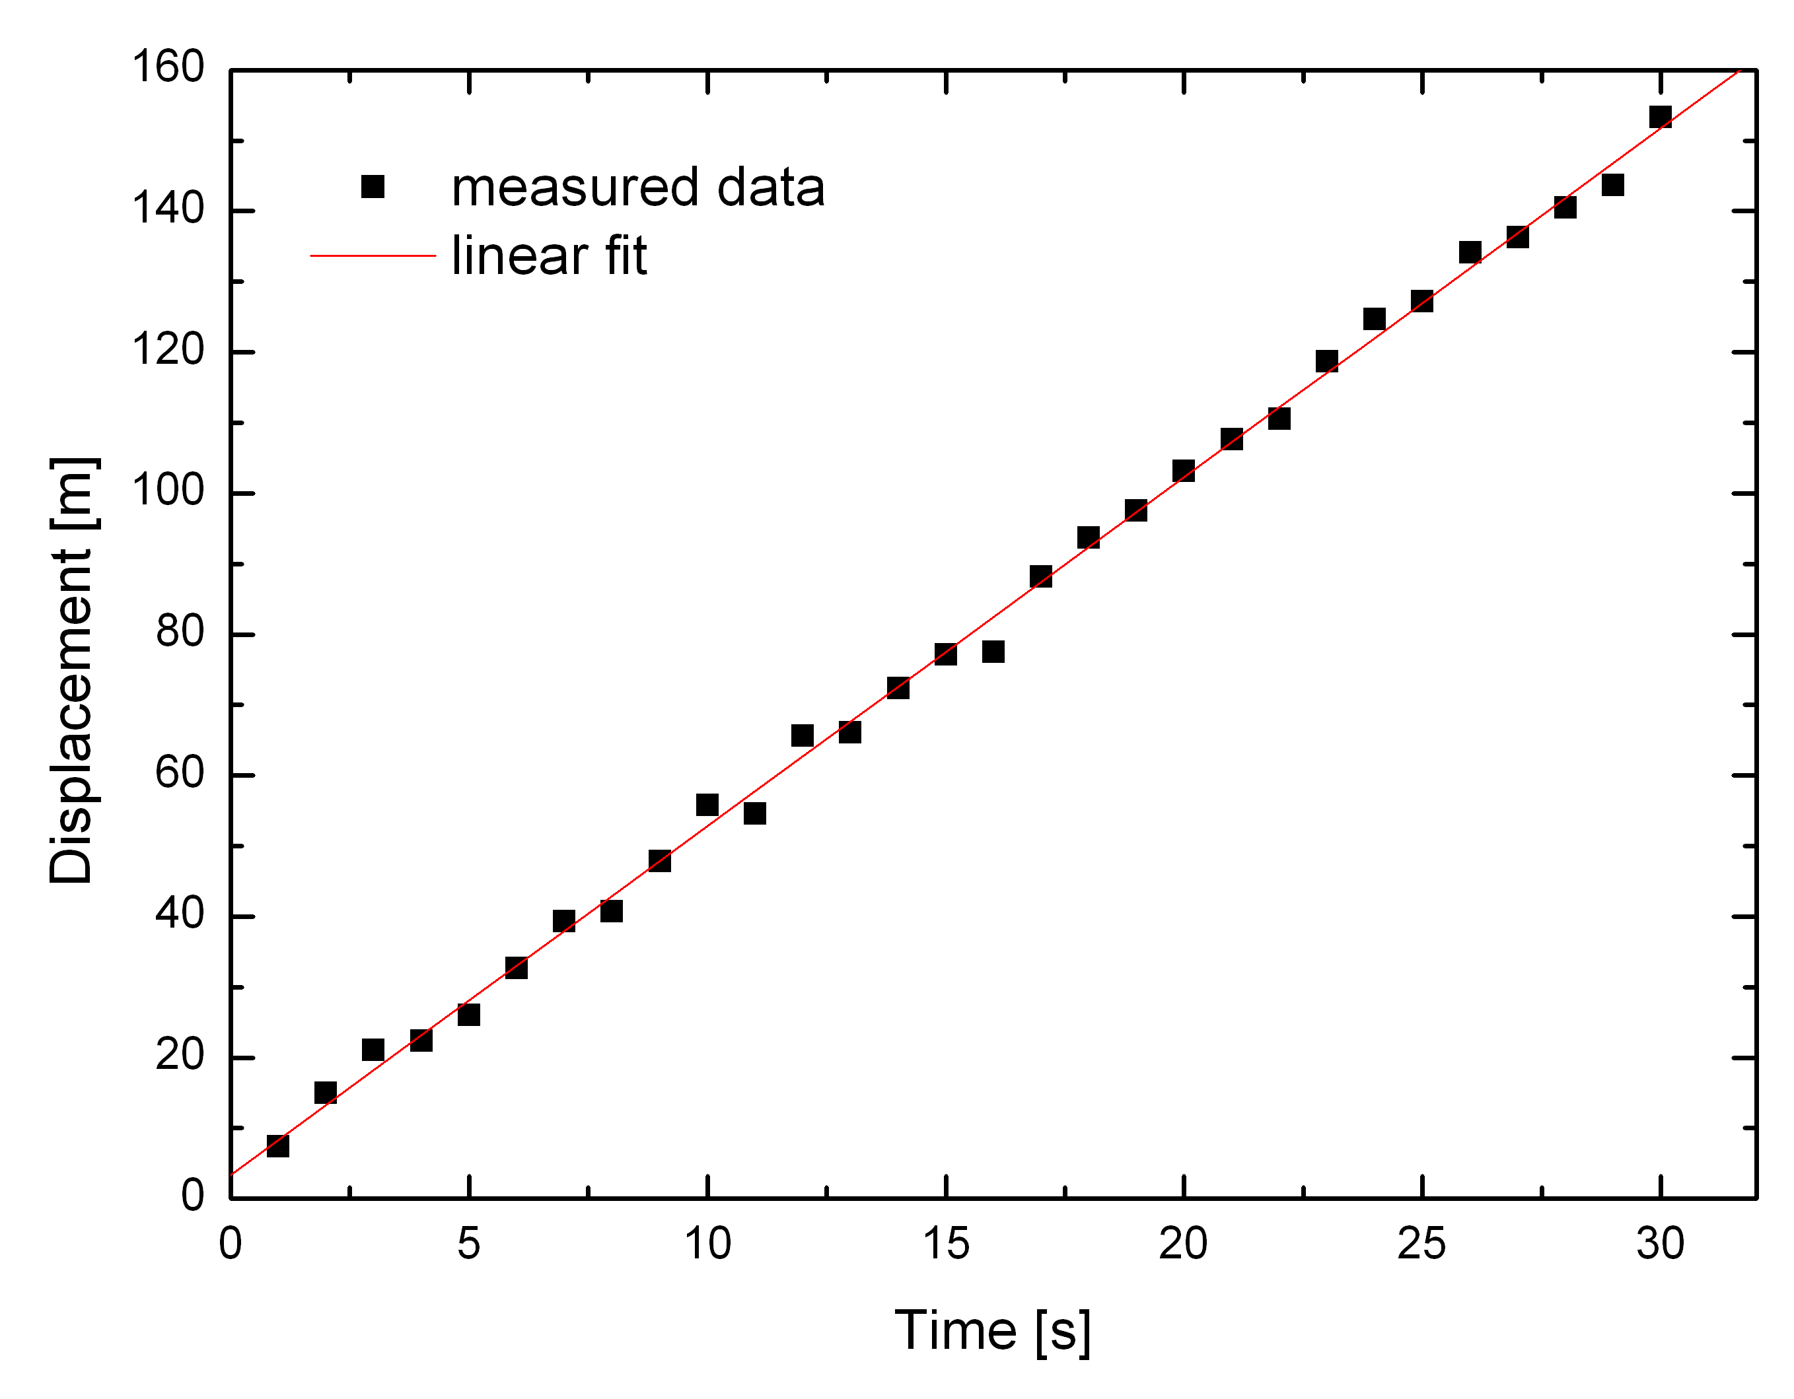
Fig. 1. The displacement of the object, x, as a function of time, t, with a linear fit (red line).
You can also add tables. When you do so, refer to them with number, e.g. Table 1 shows…
Table 1. Table caption should describe the content of the table.
- Discussion (optional)
here is the text
and here is another paragraph,
- Conclusions (or Summary and Conclusions)
here is the text
and here is another paragraph,
References
1. Author, "Title", Journal Volume, Pages (Year).
2. Author, Title (Publisher, Year).

Appendix
Here you can put additional data of importance (do not add long tables of raw data), Labview or Matlab codes, additional equations and derivations etc.

