Number of cases in the Northern Sweden Health and Disease Study, NSHDS
The information is based on available registers with varying follow-up time
In the planning of studies in the biobank, it is necessary to know approximately how many samples there are to study. As a rule, the number of available cases for a given disease is the limiting factor. Below you will find tables for some diseases and we have chosen to present information that can be produced automatically and easily. More data can be obtained for specific issues in connection with an application to the Biobank Research Unit, the Swedish Ethical Review Authority or a financier.

Table of Contents

Breast cancer, women 3
Prostate cancer 5
Pancreas cancer 7
Lung cancer 10
Colorectal cancer 13
Cervical cancer 16
Corpus cancer 18
Ovarian cancer 20
Kidney cancer 22
Bladder cancer 25
Malignant melanoma 28
Brain tumours 31
Hematological malignancies 34
All types of cancer 37
Myocardial infarction 40
Stroke 43
Osteoporotic fracture (hip+radius) 46
Diabetes 49
Parkinson’s disease 61
Comorbidity: Breastcancer, pancreascancer and myocardial infarction 64

The summaries below concerning different cancer types include only invasive tumors

Breast cancer, women

Samples and subjects

 | Total | With prospective sample | With at least 2 prospective samples | With only retrospective samples
Number of samples | 7554
Number of subjects | 3222 | 2589 | 1527 | 633
Expected at update of the register autumn 2020 |  | 2930

Extracted DNA

 | With prospective sample | With only retrospective samples
Number of subjects | 1988 | 430

Prospective plasma samples by year of sampling

Year of sampling | Number of samples | Unthawed samples of EDTA-plasma | Unthawed samples of heparin plasma
<1990 | 158 | 58 | 47
1990-1999 | 3428 | 2543 | 2650
2000-2009 | 1832 | 1767 | 1760
2010- | 214 | 214 | 214
Total | 5632 | 4582 | 4671

Age at diagnosis, for those with prospective plasma samples
< 40 | 23
40-49 | 307
50-59 | 731
60-69 | 949
70-79 | 455
80- | 124
Total | 2589

Year of diagnosis, for those with prospective samples

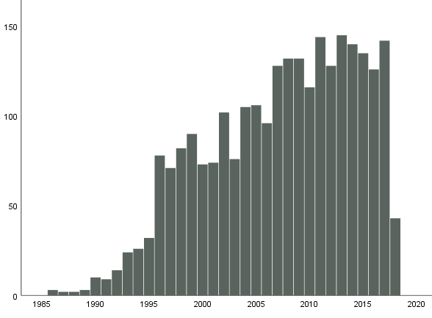
Year of diagnosis

Time (years) between the last prospective plasma sample and diagnosis
< 1 | 155
1-2 | 107
2-3 | 119
3-5 | 241
5-10 | 556
10-20 | 1051
>20 | 360
Total | 2589

Prostate cancer

Samples and subjects

 | Total | With prospective sample | With at least 2 prospective samples | With only retrospective samples
Number of samples | 4974
Number of subjects | 3344 | 3222 | 1171 | 122
Expected at update of the register autumn 2020 |  | 3847

Extracted DNA

 | With prospective sample | With only retrospective samples
Number of subjects | 2432 | 36

Prospective plasma samples by year of sampling

Year of sampling | Number of samples | Unthawed samples of EDTA-plasma | Unthawed samples of heparin plasma
<1990 | 244 | 53 | 43
1990-1999 | 2725 | 1502 | 1323
2000-2009 | 1390 | 1267 | 1072
2010- | 254 | 253 | 253
Total | 4613 | 3075 | 2691

Age at diagnosis, for those with prospective plasma samples
< 40 | 0
40-49 | 26
50-59 | 418
60-69 | 1611
70-79 | 1032
80- | 135
Total | 3222
Year of diagnosis, for those with prospective samples

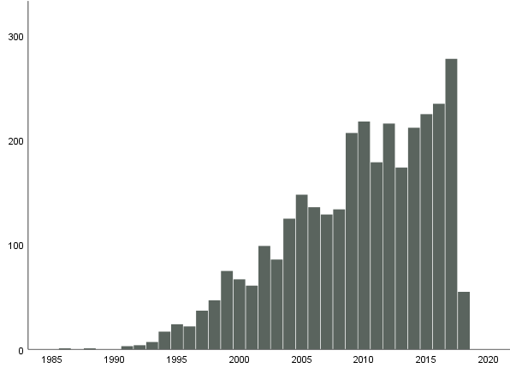
Year of diagnosis

Time (years) between the last prospective plasma sample and diagnosis
< 1 | 148
1-2 | 105
2-3 | 161
3-5 | 339
5-10 | 1046
10-20 | 1209
>20 | 214
Total | 3222

Pancreas cancer

Samples and subjects

 | Total | With prospective sample | With at least 2 prospective samples | With only retrospective samples
Number of samples | 893
Number of subjects  Men  Women | 443  177  266 | 442  176  266 | 57  168 | 1  0
Expected at update of the register autumn 2020 |  | 523

Extracted DNA

 | With prospective sample | With only retrospective samples
Number of subjects  Men  Women | 320  127  193 | 0  0  0

Prospective plasma samples by year of sampling – Men

Year of sampling | Number of samples | Unthawed samples of EDTA-plasma | Unthawed samples of heparin plasma
<1990 | 8 | 1 | 2
1990-1999 | 151 | 80 | 93
2000-2009 | 70 | 60 | 67
2010- | 15 | 15 | 14
Total | 244 | 156 | 177

Prospective plasma samples by year of sampling - Women

Year of sampling | Number of samples | Unthawed samples of EDTA-plasma | Unthawed samples of heparin plasma
<1990 | 13 | 2 | 4
1990-1999 | 436 | 358 | 385
2000-2009 | 187 | 177 | 180
2010- | 9 | 9 | 9
Total | 645 | 546 | 578

Age at diagnosis, for those with prospective plasma samples

 | Men | Women
< 40 | 2 | 1
40-49 | 6 | 10
50-59 | 22 | 37
60-69 | 86 | 103
70-79 | 53 | 89
80- | 7 | 26
Total | 176 | 266

Time (years) between the last prospective plasma sample and diagnosis

 | Men | Women
< 1 | 4 | 7
1-2 | 6 | 6
2-3 | 4 | 12
3-5 | 10 | 15
5-10 | 35 | 59
10-20 | 89 | 116
>20 | 28 | 51
Total | 176 | 266

Year of diagnosis, for those with prospective samples

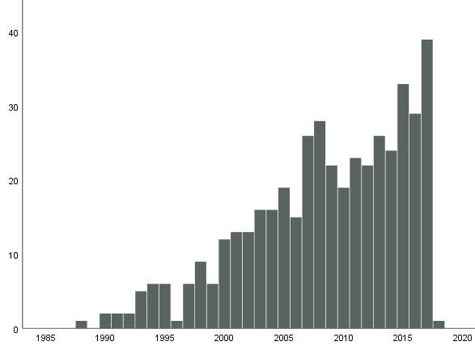
Year of diagnosis

Lung cancer

Samples and subjects

 | Total | With prospective sample | With at least 2 prospective samples | With only retrospective samples
Number of samples | 1728
Number of subjects  Men  Women | 941  404  537 | 922  396  526 | 427  103  324 | 19  8  11
Expected at update of the register autumn 2020 |  | 1084

Extracted DNA

 | With prospective sample | With only retrospective samples
Number of subjects  Men  Women | 675  305  370 | 9  4  5

Prospective plasma samples by year of sampling – Men

Year of sampling | Number of samples | Unthawed samples of EDTA-plasma | Unthawed samples of heparin plasma
<1990 | 37 | 5 | 6
1990-1999 | 316 | 167 | 211
2000-2009 | 134 | 89 | 112
2010- | 18 | 18 | 18
Total | 505 | 279 | 347

Prospective plasma samples by year of sampling - Women

Year of sampling | Number of samples | Unthawed samples of EDTA-plasma | Unthawed samples of heparin plasma
<1990 | 29 | 5 | 8
1990-1999 | 791 | 641 | 702
2000-2009 | 337 | 296 | 323
2010- | 17 | 16 | 17
Total | 1174 | 958 | 1050

Age at diagnosis, for those with prospective plasma samples

 | Men | Women
< 40 | 0 | 0
40-49 | 9 | 8
50-59 | 40 | 82
60-69 | 179 | 193
70-79 | 145 | 199
80- | 23 | 44
Total | 396 | 526

Time (years) between the last prospective plasma sample and diagnosis

 | Men | Women
< 1 | 13 | 20
1-2 | 18 | 37
2-3 | 21 | 31
3-5 | 44 | 66
5-10 | 100 | 157
10-20 | 170 | 206
>20 | 30 | 9
Total | 396 | 526

Year of diagnosis, for those with prospective samples

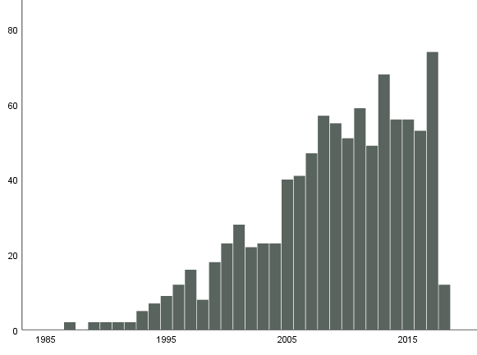
Year of diagnosis

Colorectal cancer

Samples and subjects

 | Total | With prospective sample | With at least 2 prospective samples | With only retrospective samples
Number of samples | 4393
Number of subjects  Men  Women | 2204  961  1243 | 2007  882  1125 | 998  255  743 | 197  79  118
Expected at update of the register autumn 2020 |  | 2004

Extracted DNA

 | With prospective sample | With only retrospective samples
Number of subjects  Men  Women | 1507  663  844 | 88  32  56

Prospective plasma samples by year of sampling – Men

Year of sampling | Number of samples | Unthawed samples of EDTA-plasma | Unthawed samples of heparin plasma
<1990 | 82 | 13 | 12
1990-1999 | 725 | 240 | 345
2000-2009 | 316 | 227 | 272
2010- | 49 | 46 | 49
Total | 1172 | 526 | 678

Prospective plasma samples by year of sampling - Women

Year of sampling | Number of samples | Unthawed samples of EDTA-plasma | Unthawed samples of heparin plasma
<1990 | 62 | 12 | 13
1990-1999 | 1756 | 1285 | 1447
2000-2009 | 798 | 739 | 778
2010- | 51 | 51 | 51
Total | 2667 | 2087 | 2289

Age at diagnosis, for those with prospective plasma samples

 | Men | Women
< 40 | 1 | 2
40-49 | 35 | 40
50-59 | 135 | 164
60-69 | 342 | 367
70-79 | 294 | 409
80- | 75 | 143
Total | 882 | 1125

Time (years) between the last prospective plasma sample and diagnosis

 | Men | Women
< 1 | 38 | 79
1-2 | 35 | 87
2-3 | 29 | 59
3-5 | 81 | 153
5-10 | 256 | 305
10-20 | 347 | 409
>20 | 96 | 33
Total | 882 | 1125

Year of diagnosis, for those with prospective samples

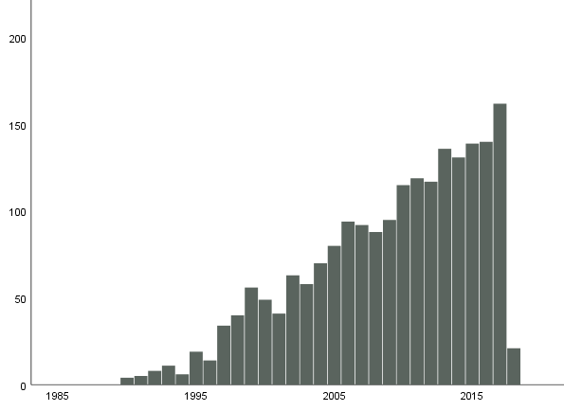
Year of diagnosis

Cervical cancer

Samples and subjects

 | Total | With prospective sample | With at least 2 prospective samples | With only retrospective samples
Number of samples | 555
Number of subjects | 252 | 104 | 46 | 148
Expected at update of the register autumn 2020 |  | 116

Extracted DNA

 | With prospective sample | With only retrospective samples
Number of subjects | 65 | 105

Prospective plasma samples by year of sampling

Year of sampling | Number of samples | Unthawed samples of EDTA-plasma | Unthawed samples of heparin plasma
<1990 | 9 | 5 | 6
1990-1999 | 115 | 86 | 104
2000-2009 | 61 | 60 | 60
2010- | 6 | 6 | 6
Total | 191 | 157 | 176

Age at diagnosis, for those with prospective plasma samples
< 40 | 5
40-49 | 26
50-59 | 24
60-69 | 22
70-79 | 20
80- | 7
Total | 104
Year of diagnosis, for those with prospective samples

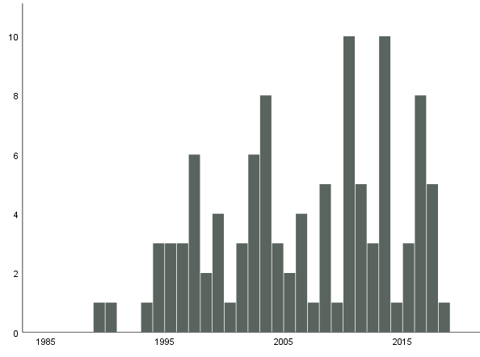
Year of diagnosis

Time (years) between the last prospective plasma sample and diagnosis
< 1 | 9
1-2 | 6
2-3 | 6
3-5 | 18
5-10 | 22
10-20 | 34
>20 | 9
Total | 104

Corpus cancer

Samples and subjects

 | Total | With prospective sample | With at least 2 prospective samples | With only retrospective samples
Number of samples | 1881
Number of subjects | 727 | 582 | 363 | 145
Expected at update of the register autumn 2020 |  | 657

Extracted DNA

 | With prospective sample | With only retrospective samples
Number of subjects | 440 | 75

Prospective plasma samples by year of sampling

Year of sampling | Number of samples | Unthawed samples of EDTA-plasma | Unthawed samples of heparin plasma
<1990 | 43 | 13 | 11
1990-1999 | 886 | 719 | 778
2000-2009 | 390 | 378 | 382
2010- | 32 | 31 | 31
Total | 1351 | 1141 | 1202

Age at diagnosis, for those with prospective plasma samples
< 40 | 1
40-49 | 13
50-59 | 148
60-69 | 235
70-79 | 142
80- | 43
Total | 582
Year of diagnosis, for those with prospective samples

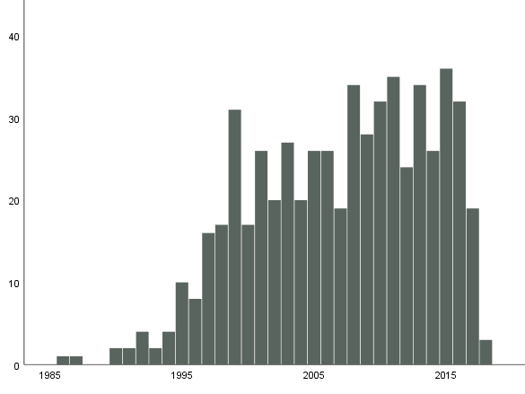
Year of diagnosis

Time (years) between the last prospective plasma sample and diagnosis
< 1 | 35
1-2 | 39
2-3 | 25
3-5 | 54
5-10 | 127
10-20 | 233
>20 | 69
Total | 582

Ovarian cancer
Borderline is not included in these tables and figures.

Samples and subjects

 | Total | With prospective sample | With at least 2 prospective samples | With only retrospective samples
Number of samples | 861
Number of subjects | 409 | 297 | 153 | 112
Expected at update of the register autumn 2020 |  | 330

Extracted DNA

 | With prospective sample | With only retrospective samples
Number of subjects | 241 | 54

Prospective plasma samples by year of sampling

Year of sampling | Number of samples | Unthawed samples of EDTA-plasma | Unthawed samples of heparin plasma
<1990 | 27 | 6 | 4
1990-1999 | 376 | 250 | 278
2000-2009 | 168 | 147 | 161
2010- | 19 | 19 | 19
Total | 590 | 422 | 462

Age at diagnosis, for those with prospective plasma samples
< 40 | 4
40-49 | 29
50-59 | 90
60-69 | 99
70-79 | 64
80- | 11
Total | 297
Year of diagnosis, for those with prospective samples

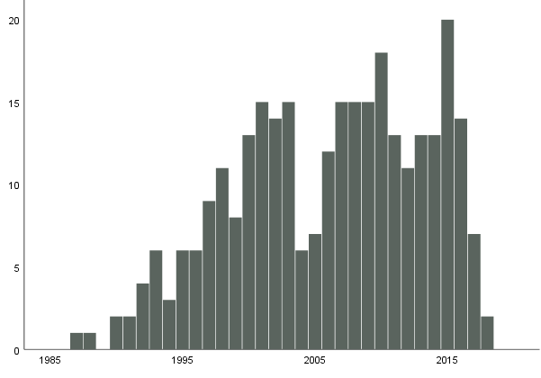
Year of diagnosis

Time (years) between the last prospective plasma sample and diagnosis
< 1 | 24
1-2 | 27
2-3 | 19
3-5 | 21
5-10 | 77
10-20 | 102
>20 | 27
Total | 297

Kidney cancer

Samples and subjects

 | Total | With prospective sample | With at least 2 prospective samples | With only retrospective samples
Number of samples | 798
Number of subjects  Men  Women | 418  228  190 | 365  202  163 | 165  61  104 | 53  26  27
Expected at update of the register autumn 2020 |  | 420

Extracted DNA

 | With prospective sample | With only retrospective samples
Number of subjects  Men  Women | 164  144  120 | 29  11  18

Prospective plasma samples by year of sampling – Men

Year of sampling | Number of samples | Unthawed samples of EDTA-plasma | Unthawed samples of heparin plasma
<1990 | 17 | 6 | 6
1990-1999 | 150 | 87 | 102
2000-2009 | 90 | 79 | 83
2010- | 15 | 15 | 15
Total | 272 | 187 | 206

Prospective plasma samples by year of sampling - Women

Year of sampling | Number of samples | Unthawed samples of EDTA-plasma | Unthawed samples of heparin plasma
<1990 | 12 | 5 | 4
1990-1999 | 247 | 203 | 226
2000-2009 | 107 | 103 | 105
2010- | 6 | 6 | 6
Total | 372 | 317 | 341

Age at diagnosis, for those with prospective plasma samples

 | Men | Women
< 40 | 1 | 0
40-49 | 9 | 2
50-59 | 40 | 26
60-69 | 86 | 68
70-79 | 61 | 53
80- | 5 | 14
Total | 202 | 163

Time (years) between the last prospective plasma sample and diagnosis

 | Men | Women
< 1 | 5 | 17
1-2 | 14 | 10
2-3 | 9 | 14
3-5 | 22 | 19
5-10 | 65 | 53
10-20 | 71 | 46
>20 | 16 | 4
Total | 202 | 163

Year of diagnosis, for those with prospective samples

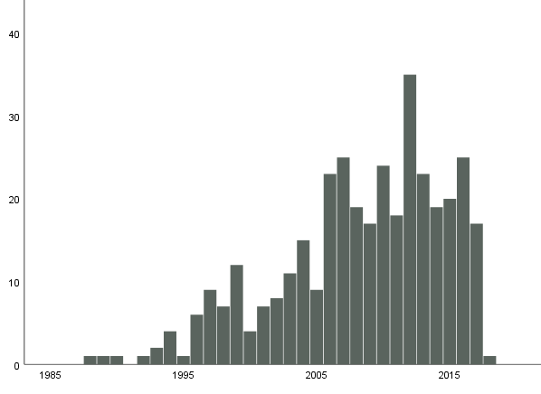
Year of diagnosis

Bladder cancer

Samples and subjects

 | Total | With prospective sample | With at least 2 prospective samples | With only retrospective samples
Number of samples | 1343
Number of subjects  Men  Women | 817  584  233 | 719  517  202 | 254  137  117 | 98  67  31
Expected at update of the register autumn 2020 |  | 883

Extracted DNA

 | With prospective sample | With only retrospective samples
Number of subjects  Men  Women | 480  349  131 | 53  39  14

Prospective plasma samples by year of sampling – Men

Year of sampling | Number of samples | Unthawed samples of EDTA-plasma | Unthawed samples of heparin plasma
<1990 | 44 | 13 | 9
1990-1999 | 438 | 222 | 273
2000-2009 | 174 | 156 | 160
2010- | 20 | 20 | 20
Total | 676 | 411 | 462

Prospective plasma samples by year of sampling - Women

Year of sampling | Number of samples | Unthawed samples of EDTA-plasma | Unthawed samples of heparin plasma
<1990 | 8 | 3 | 2
1990-1999 | 315 | 252 | 268
2000-2009 | 123 | 122 | 121
2010- | 7 | 7 | 7
Total | 453 | 384 | 398

Age at diagnosis, for those with prospective plasma samples

 | Men | Women
< 40 | 2 | 0
40-49 | 17 | 4
50-59 | 58 | 25
60-69 | 183 | 65
70-79 | 204 | 73
80- | 53 | 35
Total | 517 | 202

Time (years) between the last prospective plasma sample and diagnosis

 | Men | Women
< 1 | 19 | 8
1-2 | 20 | 16
2-3 | 13 | 9
3-5 | 40 | 25
5-10 | 139 | 53
10-20 | 230 | 78
>20 | 56 | 13
Total | 517 | 202

Year of diagnosis, for those with prospective samples

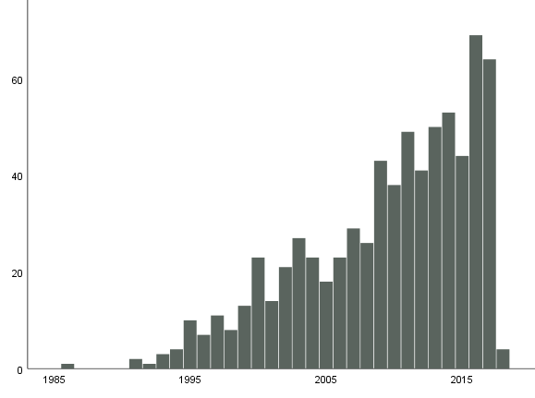
Year of diagnosis

Malignant melanoma

Samples and subjects

 | Total | With prospective sample | With at least 2 prospective samples | With only retrospective samples
Number of samples | 1468
Number of subjects  Men  Women | 755  340  415 | 568  273  295 | 267  94  173 | 187  67  120
Expected at update of the register autumn 2020 |  | 698

Extracted DNA

 | With prospective sample | With only retrospective samples
Number of subjects  Men  Women | 306  153  153 | 60  21  39

Prospective plasma samples by year of sampling – Men

Year of sampling | Number of samples | Unthawed samples of EDTA-plasma | Unthawed samples of heparin plasma
<1990 | 18 | 7 | 8
1990-1999 | 214 | 171 | 163
2000-2009 | 127 | 124 | 23
2010- | 21 | 21 | 21
Total | 380 | 323 | 315

Prospective plasma samples by year of sampling - Women

Year of sampling | Number of samples | Unthawed samples of EDTA-plasma | Unthawed samples of heparin plasma
<1990 | 19 | 12 | 12
1990-1999 | 347 | 313 | 319
2000-2009 | 225 | 224 | 222
2010- | 43 | 43 | 43
Total | 634 | 592 | 596

Age at diagnosis, for those with prospective plasma samples

 | Men | Women
< 40 | 6 | 6
40-49 | 33 | 51
50-59 | 64 | 71
60-69 | 100 | 93
70-79 | 53 | 58
80- | 17 | 16
Total | 273 | 295

Time (years) between the last prospective plasma sample and diagnosis

 | Men | Women
< 1 | 16 | 27
1-2 | 19 | 26
2-3 | 11 | 20
3-5 | 35 | 38
5-10 | 86 | 98
10-20 | 89 | 78
>20 | 17 | 8
Total | 273 | 295

Year of diagnosis, for those with prospective samples

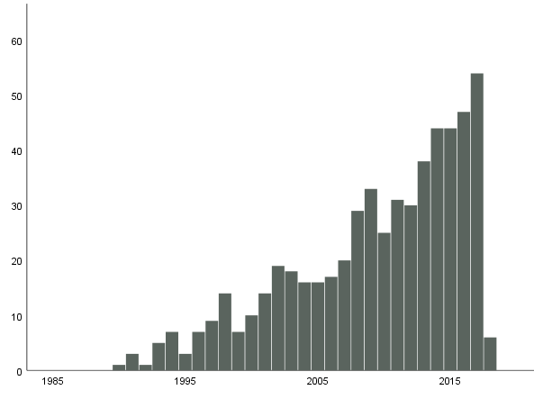
Year of diagnosis

Brain tumours

Samples and subjects

 | Total | With prospective sample | With at least 2 prospective samples | With only retrospective samples
Number of samples | 1382
Number of subjects  Men  Women | 691  267  424 | 490  194  296 | 241  55  186 | 201  73  128
Expected at update of the register autumn 2020 |  | 540

Extracted DNA

 | With prospective sample | With only retrospective samples
Number of subjects  Men  Women | 316  132  184 | 89  36  53

Prospective plasma samples by year of sampling – Men

Year of sampling | Number of samples | Unthawed samples of EDTA-plasma | Unthawed samples of heparin plasma
<1990 | 22 | 8 | 11
1990-1999 | 151 | 103 | 125
2000-2009 | 72 | 61 | 64
2010- | 18 | 18 | 18
Total | 263 | 190 | 218

Prospective plasma samples by year of sampling - Women

Year of sampling | Number of samples | Unthawed samples of EDTA-plasma | Unthawed samples of heparin plasma
<1990 | 19 | 8 | 7
1990-1999 | 411 | 349 | 389
2000-2009 | 226 | 221 | 224
2010- | 20 | 20 | 20
Total | 676 | 598 | 640

Age at diagnosis, for those with prospective plasma samples

 | Men | Women
< 40 | 6 | 2
40-49 | 26 | 37
50-59 | 47 | 83
60-69 | 66 | 109
70-79 | 45 | 60
80- | 4 | 5
Total | 194 | 296

Time (years) between the last prospective plasma sample and diagnosis

 | Men | Women
< 1 | 10 | 32
1-2 | 26 | 31
2-3 | 14 | 32
3-5 | 30 | 47
5-10 | 53 | 102
10-20 | 54 | 50
>20 | 7 | 2
Total | 194 | 296
Year of diagnosis, for those with prospective samples

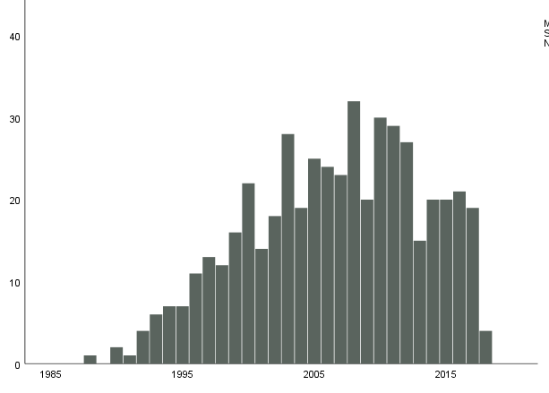
Year of diagnosis

Hematological malignancies

Samples and subjects

 | Total | With prospective sample | With at least 2 prospective samples | With only retrospective samples
Number of samples | 3190
Number of subjects  Men  Women | 1708  897  811 | 1474  774  700 | 675  250  425 | 234  123  111
Expected at update of the register autumn 2020 |  | 1723

Extracted DNA

 | With prospective sample | With only retrospective samples
Number of subjects  Men  Women | 1067  559  508 | 151  77  74

Prospective plasma samples by year of sampling – Men

Year of sampling | Number of samples | Unthawed samples of EDTA-plasma | Unthawed samples of heparin plasma
<1990 | 47 | 15 | 15
1990-1999 | 643 | 466 | 497
2000-2009 | 322 | 287 | 303
2010- | 56 | 55 | 56
Total | 1068 | 823 | 871

Prospective plasma samples by year of sampling - Women

Year of sampling | Number of samples | Unthawed samples of EDTA-plasma | Unthawed samples of heparin plasma
<1990 | 38 | 18 | 18
1990-1999 | 1019 | 874 | 934
2000-2009 | 495 | 466 | 484
2010- | 44 | 43 | 44
Total | 1596 | 1401 | 1480

Age at diagnosis, for those with prospective plasma samples

 | Men | Women
< 40 | 5 | 4
40-49 | 45 | 25
50-59 | 149 | 127
60-69 | 291 | 221
70-79 | 234 | 235
80- | 50 | 88
Total | 774 | 700

Time (years) between the last prospective plasma sample and diagnosis

 | Men | Women
< 1 | 42 | 50
1-2 | 31 | 54
2-3 | 43 | 52
3-5 | 109 | 84
5-10 | 222 | 207
10-20 | 272 | 232
>20 | 55 | 21
Total | 774 | 700
Year of diagnosis, for those with prospective samples

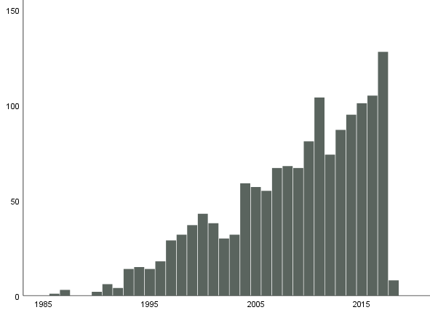
Year of diagnosis

All types of cancer

The first malign diagnosis is chosen in the tables below.

Samples and subjects

 | Total | With prospective sample | With at least 2 prospective samples | With only retrospective samples
Number of samples | 34094
Number of subjects  Men  Women | 17567  7914  9653 | 14895  7090  7805 | 7015  2314  4701 | 2672  824  1848
Expected at update of the register autumn 2020 |  | 17775

Extracted DNA

 | With prospective sample | With only retrospective samples
Number of subjects  Men  Women | 10474  4989  5485 | 1365  341 1024

Prospective plasma samples by year of sampling – Men

Year of sampling | Number of samples | Unthawed samples of EDTA-plasma | Unthawed samples of heparin plasma
<1990 | 568 | 147 | 135
1990-1999 | 5793 | 3375 | 3466
2000-2009 | 2896 | 2570 | 2475
2010- | 535 | 529 | 533
Total | 9792 | 6621 | 6609

Prospective plasma samples by year of sampling - Women

Year of sampling | Number of samples | Unthawed samples of EDTA-plasma | Unthawed samples of heparin plasma
<1990 | 478 | 166 | 153
1990-1999 | 10992 | 8794 | 9380
2000-2009 | 5350 | 5095 | 5191
2010- | 512 | 510 | 511
Total | 17332 | 14565 | 15235

Age at diagnosis, for those with prospective plasma samples

 | Men | Women
< 40 | 45 | 52
40-49 | 297 | 632
50-59 | 1151 | 1743
60-69 | 3142 | 2739
70-79 | 2095 | 2019
80- | 360 | 620
Total | 7090 | 7805

Time (years) between the last prospective plasma sample and diagnosis

 | Men | Women
< 1 | 338 | 836
1-2 | 340 | 686
2-3 | 365 | 579
3-5 | 805 | 1054
5-10 | 2208 | 2282
10-20 | 2544 | 2170
>20 | 490 | 198
Total | 7090 | 7805

Year of diagnosis, for those with prospective samples

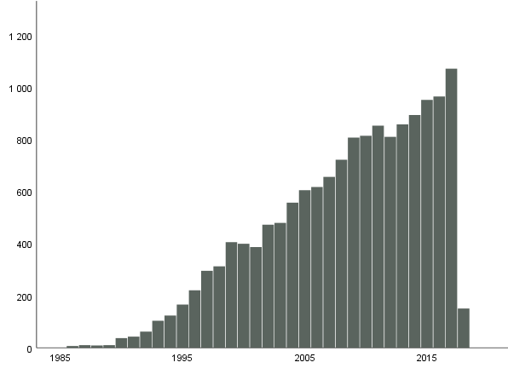
Year of diagnosis

Myocardial infarction
Before 2010, only those who were younger than 75 years were included, while from 2010 all age groups are included.

Samples and subjects

 | Total | With prospective sample | With at least 2 prospective samples | With only retrospective samples
Number of samples | 12319
Number of subjects  Men  Women | 6943  4549  2394 | 3944  2211 | 1153  1387 | 788  605  183
Expected at update of the register autumn 2020 |  | 7055

Extracted DNA

 | With prospective sample | With only retrospective samples
Number of subjects  Men  Women | 4598  2882  1716 | 591  434  157

Prospective plasma samples by year of sampling - Men

Year of sampling | Number of samples | Unthawed samples of EDTA-plasma | Unthawed samples of heparin plasma
<1990 | 311 | 83 | 65
1990-1999 | 3261 | 1738 | 1956
2000-2009 | 1467 | 1368 | 1326
2010- | 254 | 254 | 254
Total | 5293 | 3443 | 3601

Prospective plasma samples by year of sampling - Women

Year of sampling | Number of samples | Unthawed samples of EDTA-plasma | Unthawed samples of heparin plasma
<1990 | 128 | 44 | 38
1990-1999 | 3552 | 2889 | 3068
2000-2009 | 1357 | 1312 | 1328
2010- | 71 | 70 | 71
Total | 5108 | 4324 | 4505

Age at diagnosis, for those with prospective plasma samples

 | Men | Women
< 40 | 6 | 5
40-49 | 235 | 63
50-59 | 965 | 318
60-69 | 1613 | 617
70-79 | 913 | 774
80- | 212 | 434
Total | 3944 | 2211

Time (years) between the last prospective plasma sample and diagnosis

 | Men | Women
< 1 | 210 | 134
1-2 | 232 | 134
2-3 | 252 | 109
3-5 | 539 | 252
5-10 | 1210 | 565
10-20 | 1227 | 939
>20 | 274 | 78
Total | 3944 | 2211

Year of diagnosis, for those with prospective samples

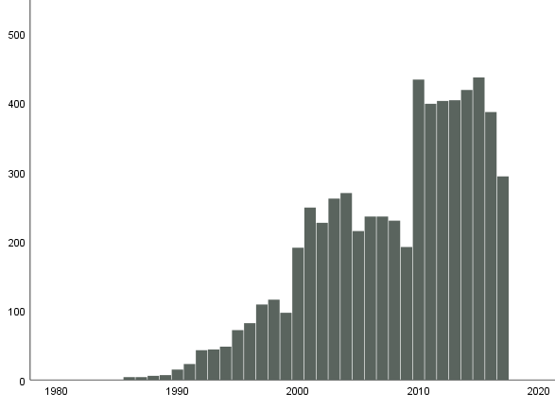
Year of diagnosis

Stroke
Before 2010, only those who were younger than 75 years were included, while from 2010 all age groups are included. In addition, transient cerebral ischemic attack (TIA) was not included in the register until 2010.

Samples and subjects

 | Total | With prospective sample | With at least 2 prospective samples | With only retrospective samples
Number of samples | 14869
Number of subjects  Men  Women | 7798  3817  3981 | 7012  3413  3599 | 3200  964  2236 | 786  404  382
Expected at update of the register autumn 2020 |  | 8312

Extracted DNA

 | With prospective sample | With only retrospective samples
Number of subjects  Men  Women | 5047  2398  2649 | 562  275  287

Prospective plasma samples by year of sampling – Men

Year of sampling | Number of samples | Unthawed samples of EDTA-plasma | Unthawed samples of heparin plasma
<1990 | 267 | 67 | 62
1990-1999 | 2801 | 1652 | 1784
2000-2009 | 1231 | 1157 | 1122
2010- | 216 | 216 | 216
Total | 4515 | 3092 | 3184

Prospective plasma samples by year of sampling - Women

Year of sampling | Number of samples | Unthawed samples of EDTA-plasma | Unthawed samples of heparin plasma
<1990 | 213 | 77 | 62
1990-1999 | 5670 | 4794 | 5099
2000-2009 | 2301 | 2235 | 2260
2010- | 142 | 142 | 142
Total | 8326 | 7248 | 7563

Age at diagnosis, for those with prospective plasma samples

 | Men | Women
< 40 | 14 | 15
40-49 | 129 | 138
50-59 | 563 | 403
60-69 | 1319 | 992
70-79 | 1089 | 1259
80- | 299 | 792
Total | 3413 | 3599

Time (years) between the last prospective plasma sample and diagnosis

 | Men | Women
< 1 | 137 | 191
1-2 | 150 | 217
2-3 | 148 | 191
3-5 | 336 | 330
5-10 | 959 | 881
10-20 | 1325 | 1637
>20 | 358 | 152
Total | 3413 | 3599

Year of diagnosis, for those with prospective samples

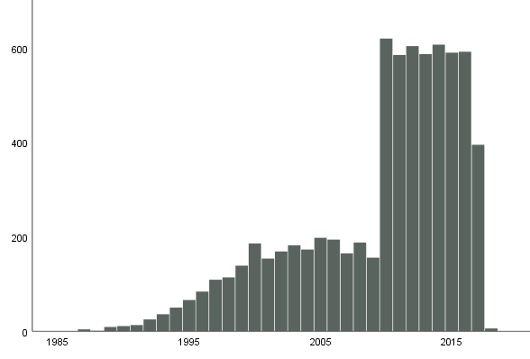
Year of diagnosis

Osteoporotic fracture (hip+radius)

Samples and subjects

 | Total | With prospective sample | With at least 2 prospective samples | With only retrospective samples
Number of samples | 13287
Number of subjects  Men  Women | 6048  1494  4554 | 5415  1236  4179 | 2949  300  2649 | 633  258  375
Expected at update of the register autumn 2020 |  | 6300

Extracted DNA

 | With prospective sample | With only retrospective samples
Number of subjects  Men  Women | 4134  907  3227 | 447  133  314

Prospective plasma samples by year of sampling – Men

Year of sampling | Number of samples | Unthawed samples of EDTA-plasma | Unthawed samples of heparin plasma
<1990 | 89 | 35 | 32
1990-1999 | 983 | 570 | 619
2000-2009 | 427 | 396 | 388
2010- | 84 | 84 | 84
Total | 1583 | 1085 | 1123

Prospective plasma samples by year of sampling - Women

Year of sampling | Number of samples | Unthawed samples of EDTA-plasma | Unthawed samples of heparin plasma
<1990 | 207 | 100 | 89
1990-1999 | 6603 | 5626 | 5943
2000-2009 | 2604 | 2532 | 2547
2010- | 143 | 141 | 142
Total | 9557 | 8399 | 8721

Age at diagnosis, for those with prospective plasma samples

 | Men | Women
< 40 | 10 | 5
40-49 | 45 | 42
50-59 | 229 | 676
60-69 | 387 | 1217
70-79 | 364 | 1343
80- | 201 | 896
Total | 1236 | 4179

Time (years) between the last prospective plasma sample and diagnosis

 | Men | Women
< 1 | 51 | 289
1-2 | 54 | 273
2-3 | 46 | 258
3-5 | 136 | 461
5-10 | 284 | 1024
10-20 | 433 | 1596
>20 | 232 | 278
Total | 1236 | 4179

Year of diagnosis, for those with prospective samples

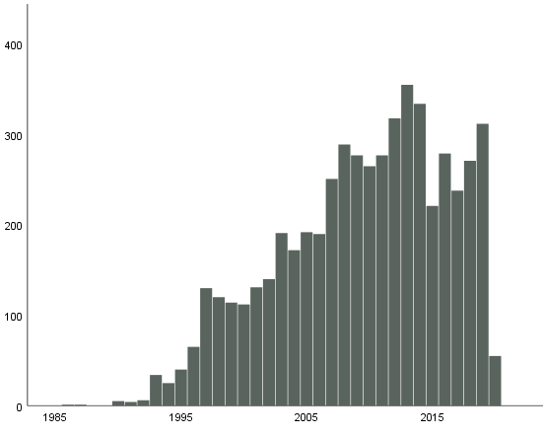
Year of diagnosis

Diabetes
The diagnosis is verified on the basis of analyzes of the blood sample that has been submitted closest to the diagnosis, regardless of whether the date of sampling was before or after the discovery of the disease. There are significantly fewer cases after 2006 because the cases verified in DiabNorr after 2006 mostly consist of individuals with participated in the Monica-project.

Samples and subjects

 | Total | With prospective sample | With at least 2 prospective samples | With only retrospective samples
Number of samples | 6627
Number of subjects  Men  Women | 3339  1942  1397 | 1201  981 | 227  576 | 1157  741  416
Expected at update of the register autumn 2020 |  | 5110

Extracted DNA

 | With prospective sample | With only retrospective samples
Number of subjects  Men  Women | 1934  1071  863 | 1026  661  365

Prospective plasma samples by year of sampling - Men

Year of sampling | Number of samples | Unthawed samples of EDTA-plasma | Unthawed samples of heparin plasma
<1990 | 140 | 20 | 11
1990-1999 | 1180 | 556 | 444
2000-2009 | 157 | 131 | 49
2010- | 3 | 3 | 3
Total | 1480 | 710 | 507

Prospective plasma samples by year of sampling - Women

Year of sampling | Number of samples | Unthawed samples of EDTA-plasma | Unthawed samples of heparin plasma
<1990 | 85 | 16 | 13
1990-1999 | 1617 | 1172 | 1145
2000-2009 | 371 | 351 | 313
2010- | 1 | 1 | 1
Total | 2074 | 1540 | 1472

Age at diagnosis, for those with prospective plasma samples

 | Men | Women
< 40 | 17 | 8
40-49 | 153 | 114
50-59 | 440 | 361
60-69 | 475 | 399
70-79 | 106 | 90
80- | 10 | 9
Total | 1201 | 981

Time (years) between the last prospective plasma sample and diagnosis

 | Men | Women
< 1 | 76 | 76
1-2 | 43 | 80
2-3 | 70 | 56
3-5 | 166 | 132
5-10 | 516 | 408
10-20 | 307 | 212
>20 | 23 | 17
Total | 1201 | 981

Year of diagnosis, for those with prospective samples

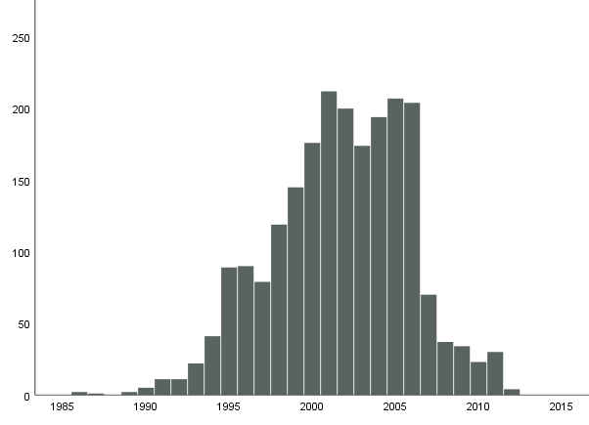
Year of diagnosis

Alzheimer's disease

Samples and subjects

 | Total | With prospective sample | With at least 2 prospective samples | With only retrospective samples
Number of samples | 679
Number of subjects  Men  Women | 393  103  290 | 386  101  285 | 172  14  158 | 7  2  5
Expected at update of the register autumn 2020 |  | 1070

Extracted DNA

 | With prospective sample | With only retrospective samples
Number of subjects  Men  Women | 377  96  281 | 3  0  3

Prospective plasma samples by year of sampling – Men

Year of sampling | Number of samples | Unthawed samples of EDTA-plasma | Unthawed samples of heparin plasma
<1990 | 10 | 3 | 3
1990-1999 | 100 | 26 | 43
2000-2009 | 9 | 5 | 7
2010- | 0 | 0 | 0
Total | 119 | 34 | 53

Prospective plasma samples by year of sampling - Women

Year of sampling | Number of samples | Unthawed samples of EDTA-plasma | Unthawed samples of heparin plasma
<1990 | 19 | 7 | 7
1990-1999 | 444 | 298 | 383
2000-2009 | 73 | 63 | 69
2010- | 0 | 0 | 0
Total | 536 | 368 | 459

Age at diagnosis, for those with prospective plasma samples

 | Men | Women
< 40 | 0 | 0
40-49 | 1 | 0
50-59 | 7 | 15
60-69 | 45 | 82
70-79 | 47 | 178
80- | 1 | 10
Total | 101 | 285

Time (years) between the last prospective plasma sample and diagnosis

 | Men | Women
< 1 | 2 | 12
1-2 | 4 | 15
2-3 | 3 | 22
3-5 | 9 | 51
5-10 | 37 | 124
10-20 | 45 | 61
>20 | 1 | 0
Total | 101 | 285

Year of diagnosis, for those with prospective samples

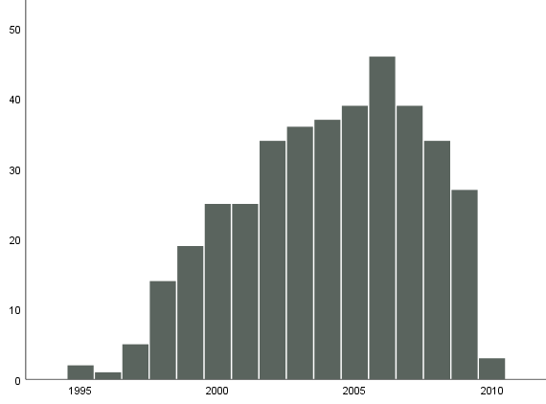
Year of diagnosis

Atrial fibrillation

Samples and subjects

 | Total | With prospective sample | With at least 2 prospective samples | With only retrospective samples
Number of samples | 10153
Number of subjects  Men  Women | 5054  3108  1946 | 5016  3079  1937 | 2216  767  1449 | 38  29  9
Expected at update of the register autumn 2020 |  | 7266

Extracted DNA

 | With prospective sample | With only retrospective samples
Number of subjects  Men  Women | 3642  2177  1465 | 6  3  3

Prospective plasma samples by year of sampling – Men

Year of sampling | Number of samples | Unthawed samples of EDTA-plasma | Unthawed samples of heparin plasma
<1990 | 222 | 92 | 80
1990-1999 | 2551 | 1512 | 1556
2000-2009 | 1069 | 1000 | 963
2010- | 94 | 94 | 94
Total | 3936 | 2698 | 2693

Prospective plasma samples by year of sampling - Women

Year of sampling | Number of samples | Unthawed samples of EDTA-plasma | Unthawed samples of heparin plasma
<1990 | 150 | 72 | 61
1990-1999 | 3708 | 3113 | 3300
2000-2009 | 1429 | 1385 | 1386
2010- | 44 | 44 | 44
Total | 5331 | 4614 | 4791

Age at diagnosis, for those with prospective plasma samples

 | Men | Women
< 40 | 15 | 5
40-49 | 167 | 43
50-59 | 553 | 234
60-69 | 1313 | 710
70-79 | 927 | 788
80- | 104 | 157
Total | 3079 | 1937

Time (years) between the last prospective plasma sample and diagnosis

 | Men | Women
< 1 | 142 | 125
1-2 | 161 | 130
2-3 | 177 | 126
3-5 | 341 | 247
5-10 | 960 | 611
10-20 | 1147 | 651
>20 | 151 | 47
Total | 3079 | 1937

Year of diagnosis, for those with prospective samples

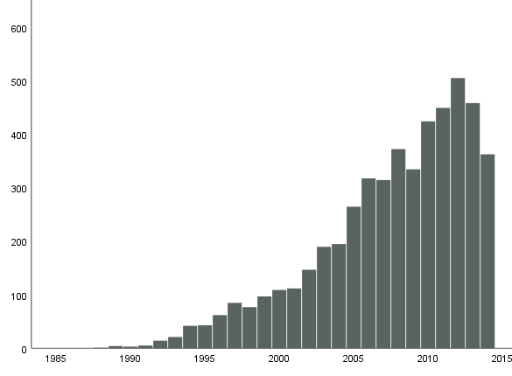
Year of diagnosis

Rheumatoid arthritis

Samples and subjects

 | Total | With prospective sample | With at least 2 prospective samples | With only retrospective samples
Number of samples | 1855
Number of subjects  Men  Women | 823  228  595 | 591  175  416 | 306  48  258 | 232  53  179
Expected at update of the register autumn 2020 |  | 1105

Extracted DNA

 | With prospective sample | With only retrospective samples
Number of subjects  Men  Women | 577  171  406 | 138  28  110

Prospective plasma samples by year of sampling – Men

Year of sampling | Number of samples | Unthawed samples of EDTA-plasma | Unthawed samples of heparin plasma
<1990 | 20 | 8 | 9
1990-1999 | 143 | 34 | 63
2000-2009 | 59 | 29 | 43
2010- | 3 | 3 | 3
Total | 225 | 74 | 118

Prospective plasma samples by year of sampling - Women

Year of sampling | Number of samples | Unthawed samples of EDTA-plasma | Unthawed samples of heparin plasma
<1990 | 27 | 7 | 7
1990-1999 | 632 | 209 | 407
2000-2009 | 231 | 107 | 188
2010- | 1 | 0 | 1
Total | 891 | 323 | 603

Age at diagnosis, for those with prospective plasma samples

 | Men | Women
< 40 | 5 | 15
40-49 | 28 | 67
50-59 | 49 | 125
60-69 | 72 | 148
70-79 | 21 | 59
80- | 0 | 2
Total | 175 | 416

Time (years) between the last prospective plasma sample and diagnosis

 | Men | Women
< 1 | 17 | 63
1-2 | 12 | 59
2-3 | 17 | 47
3-5 | 30 | 79
5-10 | 65 | 118
10-20 | 33 | 50
>20 | 1 | 0
Total | 175 | 416

Year of diagnosis, for those with prospective samples

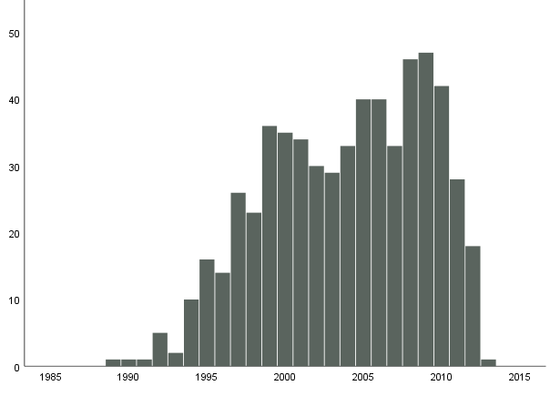
Year of diagnosis

Parkinson’s disease

Samples and subjects

 | Total | With prospective sample | With at least 2 prospective samples | With only retrospective samples
Number of samples | 1242
Number of subjects  Men  Women | 637  341  297 | 552  299  253 | 245  80  165 | 86  42  44
Expected at update of the register autumn 2020 |  | 850

Extracted DNA

 | With prospective sample | With only retrospective samples
Number of subjects  Men  Women | 390  217  173 | 50  23  27

Prospective plasma samples by year of sampling – Men

Year of sampling | Number of samples | Unthawed samples of EDTA-plasma | Unthawed samples of heparin plasma
<1990 | 16 | 5 | 4
1990-1999 | 261 | 89 | 148
2000-2009 | 104 | 83 | 95
2010- | 6 | 6 | 6
Total | 387 | 183 | 253

Prospective plasma samples by year of sampling - Women

Year of sampling | Number of samples | Unthawed samples of EDTA-plasma | Unthawed samples of heparin plasma
<1990 | 13 | 5 | 6
1990-1999 | 440 | 316 | 375
2000-2009 | 166 | 155 | 164
2010- | 4 | 3 | 3
Total | 623 | 479 | 548

Age at diagnosis, for those with prospective plasma samples

 | Men | Women
< 40 | 1 | 1
40-49 | 13 | 5
50-59 | 62 | 37
60-69 | 139 | 116
70-79 | 81 | 82
80- | 3 | 12
Total | 299 | 253

Time (years) between the last prospective plasma sample and diagnosis

 | Men | Women
< 1 | 8 | 18
1-2 | 19 | 28
2-3 | 15 | 19
3-5 | 42 | 40
5-10 | 125 | 100
10-20 | 85 | 48
>20 | 5 | 0
Total | 299 | 253

Year of diagnosis, for those with prospective samples

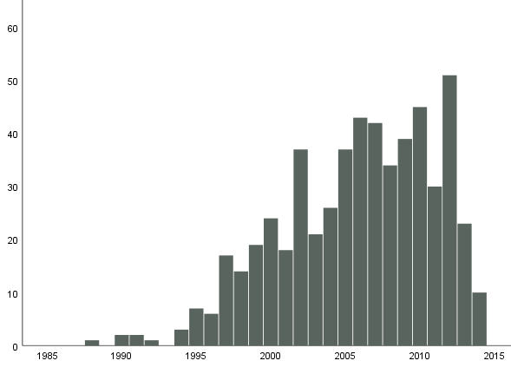
Year of diagnosis

Comorbidity: Breastcancer, pancreascancer and myocardial infarction

 | Breastcancer | Pancreascancer | Infarct
Breastcancer | na | 17 | 140
Pancreascancer | 17 | na | 25
Myocardial infarction | 140 | 25 | na

