# Methods used in the Northern Sweden Health and Disease study (NSHDS)

This document is a summary of methods and algorithms constructed for optimal use of the phenotypic data stored for participants in the NSHDS biobank. There are a few shifts in methodology used during the period samples and data have been collected, which are relevant primarily in the time-trend analyses. These shifts are related to blood pressure and blood lipids, and are described in detail later on in this document. Further information of the NSHDS cohorts can be found at the webpage: https://www.umu.se/en/biobank-research-unit/

Version 2, edited 2020-01-20 and 2020-10-02

Editor: Anders Johansson

Scientific board: Stefan Söderberg, Johan Hultdin & Patrik Wennberg

Referees: Kjell Grankvist, Medicinsk Biovetenskap, Umeå Universitet

Marie Eriksson, Statistik/Handelshögskolan, Umeå Universitet.

Robert Johansson and Ingvar Bergdahl, both at the Biobank Research Unit, took part in the discussions and recalculation of statistics during the revision year 2020.

**Content**:

Methods used in the VIP study page 2-3

Methods used in the MONICA study page 4-5

Methods used in the “Mammographic screening project” page 6

Recommendations for interpretation of outlier values page 6

Conversion of blood pressure, recumbent to sitting-VIPpage 7

Algorithms for conversion of blood lipids-VIPpage 8

Transformation of data blood lipids-MONICA page 9-11

**Västerbotten Intervention Program (VIP), Methods for CVD risk factors**

|  |
| --- |
| **Cohort** |
| 1985-1991: examinations could be performed either in the morning or after lunch and hence the fasting period was at least 8 hours or at least 4 hours, respectively.  From 1992: A fasting period of minimum of 8 hours before blood sampling required. In practice, this implies an overnight fast and blood sampling is done in the morning. |
| **Blood pressure** |
| 1985-2000 measured manually once usually to the nearest 5 or 10 mm with a mercury sphygmomanometer after 5 min rest with the subject in a recumbent position. During 2000-2008 the health care centers increasingly and after their own decisions shifted to automated digital blood pressure measurements using calibrated devices. From 2009 09 01: Measured twice with mercury sphygmomanometer (precision 2 mm) or automated digital blood pressure measurements using calibrated devices after 5 min rest with the subject in a sitting position. The mean of the two measurements of systolic and diastolic blood pressures are recorded.  Transformation algorithms are available at EBF to be used on study populations including data both before and after this date (see page 2). |
| **Blood-glucose** |
| 1985-Oral glucose Tolerance test performed according to WHO standards (2).  Fasting and 2-hour glucose analyzed on capillary plasma on a Reflotron Bench top analyzer  (Roche Diagnostics).  From. 2004: Fasting and 2-hour glucose analyzed on a Hemocue  bench-top HemoCue® Glucose analyzer (HemoCue AB, Ängelholm, Sweden) (1).  Reflotron and Hemocue analyzers regularly tested in a calibration scheme provided by  EQUALIS, the External Quality Assurance in Laboratory Medicine in Sweden. |
| **Plasma lipids** |
| 1985-P-Cholesterol and P-Triglycerides were analyzed on a Reflotron Bench top analyzer  (Roche Diagnostics).  From 2009-09-01: Lipids (P-cholesterol, P-triglycerides, P-LDL-cholesterol and P-HDL-cholesterol) analyses with routine methods at clinical chemistry department of the local hospital.  We have examined the material where there are measurement values (P-chol, P-triglyc.) from both methods and the difference in mean and median values is only 2-3%. Therefore, we recommend that you do not use any algorithm, but the methods are comparable. However, it should be kept in mind that for triglycerides, the min value with the old method is = 0.8. |
| **Height** |
| 1985-Without shoes. Measured to the nearest cm using a calibrated wall mounted height rod or height rod that is mount onto the scale. |
| **Weight** |
| 1985-Light indoor clothing. Measured to the nearest kg using a calibrated scale. |
| **Waist** |
| From 2003-Measured with an inelastic tape, on the skin, to the nearest cm, in the midway between the lowest palpable rib and top of the iliac crest. The subject in a standing position and after a calm exhalation. |

**References**, Västerbotten Intervention Program (VIP)

1. Norberg M, Wall S, Boman K, Weinehall L. The Vasterbotten Intervention Programme: background, design and implications. Glob Health Action. 2010;3.

2. World Health Organization: Definition, Diagnosis and Classification of Diabetes Mellitus and its Complications: Report of a WHO Consultation. Part 1: Diagnosis and Classification of Diabetes Mellitus. Geneva, World Health Org., 1999.

**MONICA, Methods for CVD risk factors**

|  |
| --- |
| **Cohort (1, 2)** |
| Participants were randomly assigned examination in the morning or after lunch and hence the fasting period was at least 8 hours or at least 4 hours, respectively.  In practice, this implies an overnight fast for those examined in the morning (approximately 60% of all participants). |
| **Blood pressure** |
| In the surveys 1986 to 2004, blood pressure was measured twice in the sitting position, after a 5-min rest, using the Hawksley random-zero sphygmomanometer, and the mean value was recorded.  From 2009 onwards, the Omron M7 monitor was used. Hypertension was defined as mean systolic blood pressure ≥140 mmHg and⁄ or mean diastolic blood pressure ≥90 mmHg, and⁄ or treatment with antihypertensive medication during the 2 weeks before the survey. In 2009, blood pressure was measured with both methods in a subsample (3). |
| **Blood-glucose** |
| An Oral Glucose Tolerance Test (OGTT) was performed according to WHO standards in those randomly assigned a morning examination time (4).  Venous plasma was used for glucose analysis and, until 1999, the hexokinase method (Boehringer Mannheim Automated analysis for BM/Hitachi system 717) was used in a single laboratory. Since 2004, a Hemocue benchtop analyser (Quest Diagnostics, Madison,NJ, USA) was used. In 2004, a parallel analysis was undertaken in 195 oral glucose tolerance test samples using both the old Boehringer and the new Hemocue methods. The Pearson correlation coefficients for fasting plasma glucose and 2-h post-load plasma glucose for the two methods were 0.84 and 0.98, respectively (all P < 0.0005). Linear regression-derived equations using glucose concentrations with the old method and the new method have been constructed (5). |
| **Plasma lipids** |
| All measurements of total cholesterol have been done at a central laboratory. Between 1986 and 1994, total cholesterol was determined by an enzymatic method (BM Monotest Cholesterol CHOD-PAP, Boehringer Mannheim, GmbH, Germany), and since 1999 a dry chemistry method was used (Vitros 950, Kodak Echtachem, USA). The measurement of total cholesterol is accredited by the national accreditation body, with a CV of 3.6% at 3.9 mmol/L and 3.1% at 6.7 mmol/L (7-8). HDL was measured 1986, 1990, and 1994, and TG was measured 1986, 1990, 1994, 1999 and 2004. See page 9–11, cholesterol results from the 1986, 1990 and 1994 surveys have been converted to the new method used from 1999 (1.4% adjustment). |
| **Height** |
| Height was measured without shoes to the nearest cm using a calibrated wall mounted height rod or height rod that is mount onto the scale. |
| **Weight** |
| The subjects wore light clothes and no shoes, and weight was measured to the nearest 0.1 kg on a balance scale (calibrated daily) from 1986 to 1994, and on an electronic scale from 1999 onwards. |
| **Waist** |
| The waist and hip circumferences were measured in standing position with the feet fairly close together (12−15 cm apart). Tight undergarments were released or taken off before measuring the waist circumference, which was measured midway between the lower rib margin and the iliac crest. At the time of measuring, the subject was asked to exhale gently. The hip circumference was measured at the maximum circumference over the buttocks to the nearest 0.5 cm. |

**References, MONICA**

1. Eriksson M, Holmgren L, Janlert U, Jansson JH, Lundblad D, Stegmayr B, et al. Large improvements in major cardiovascular risk factors in the population of northern Sweden: the MONICA study 1986-2009. Journal of internal medicine. 2011;269(2):219-31.

2. Stegmayr B, Lundberg V, Asplund K. The events registration and survey procedures in the Northern Sweden MONICA Project. Scand J Public Health Suppl. 2003;61:9-17.

3. Eriksson M, Carlberg B, Jansson JH. Comparison of blood pressure measurements between an automated oscillometric device and a Hawksley random-zero sphygmomanometer in the northern Sweden MONICA study. Blood Press Monit. 2012;17(4):164-70.

4. World Health Organization: Definition, Diagnosis and Classification of Diabetes Mellitus and its Complications: Report of a WHO Consultation. Geneva, World Health Org, 1999.

5. Lilja M, Eliasson M, Eriksson M, Soderberg S. A rightward shift of the distribution of fasting and post-load glucose in northern Sweden between 1990 and 2009 and its predictors. Data from the Northern Sweden MONICA study. Diabet Med. 2013;30(9):1054-62.

**Mammographic Screening Project**

|  |
| --- |
| **Cohort** |
| Samples (mostly nonfasting) and data are collected in connection with mammography screenings 1995-2006 |
| **Height** |
| All years self- reported |
| **Weight** |
| All years self- reported |

**Recommendations for interpretation of outlier values**

Values within the indicated levels below are suggested to be handled as missing values. All outliers have been checked for possible mistake in the data handling.

Parameter Value

Height <130 cm or >210 cm

Weight <35 Kg

Body Mass Index >70

S-Cholesterol <2.0 mmol/L

HDL >7 mmol/L

S-Triglycerides <0.15 mmol/L or >20 mmol/L

**Conversion of sitting to recumbent blood pressure values and vice versa (VIP)**

In the VIP-cohort, blood pressure was measured with subjects in recumbent (supine) position until September 1st 2009 and from that date with subjects in sitting position.

The differences in blood pressure values between measurements in the two various positions, recumbent or sitting, are negligible in a clinical point of view. However, in a dataset from the VIP-cohort where blood pressure was measured on the same individuals in the two different positions, a significant difference for both the systolic and diastolic values was found. Based on this calculation the diastolic value was in average 2.5 mm higher measured at sitting position and the systolic value 0.8 mm higher in this position. This is in line with previous findings on different populations (1, 2). In these studies, the diastolic values were higher when measured in sitting position, while the effect on the systolic blood pressure showed a slight decreased. We therefore recommend an addition with 2.5 mm for conversion of the diastolic blood pressure from recumbent to sitting position, and no need for conversion for the systolic measurements.

A data set with blood pressure values from 653 VIP-participants at age 40, 50 or 60 years and measured in both positions is available after contacting EBF.

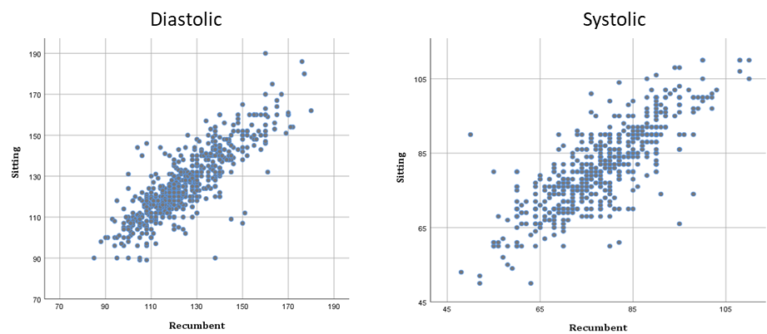

*The figures show correlation between the blood pressure values measured in two various position, recumbent or sitting. The illustrations are based on a data set with 653 VIP-participants at age 40, 50 or 60 years, measured at both positions.*

**References VIP**:

1. Kahan T. Rätt mätt blodtryck tack! Läkartidningen 2009; 106: 1349-1350.
2. Kuwabaraa,M, Haradab K, Hishikib Y, Karioa K. Validation of an automatic device for the self-measurement of blood pressure in sitting and supine positions according to the ANSI/AAMI/ISO81060-2:2013 guidelines: the Omron HEM-9700T. Blood Pressure Monitoring 2019; 24: 146–150.

**Cholesterol and triglycerides in the VIP-cohort, correlation between two different methods for measurement**

Various methods have been used to calculate cholesterol and triglyceride values before and after 2009-09-01. We have previously recommended a certain algorithm to be able to compare older data with newer ones, where different methods have been used.

The algorithm has been calculated by linear regression but since there are random errors in both parameters, this method is not always optimal.

We have examined the material where there are measurement values from both methods and the difference in mean and median values is only 2-3%. The previous recommendation introduced a larger error, 7-10%, than the real difference.

Therefore, we recommend not to use any algorithm for VIP data. The methods are comparable. However, it should be kept in mind that for triglycerides, the min value with the old method is = 0.8.

Blood lipids were measured by two methods; 1985 – 2009-08-31 on a reflotron at local health centers. Samples with high cholesterol (>6.5 mmol/l) and/or triglycerides values were re-analyzed at Clinical Chemistry Laboratory for cholesterol, triglycerides and HDL. Reference value for high cholesterol in individuals with known cardiovascular disease was set at >5.2 mmol/l. From 2009-09-01 blood lipids were analyzed by an enzymatic method at Clinical Chemistry Laboratory.

A dataset with samples that are analyzed with both methods is available. Regarding triglycerides there are data from 838 VIP-participants and regarding cholesterol from 1197 VIP-participants. This dataset is stored at EBF and available after contacting the unit.

|  |
| --- |
|  |

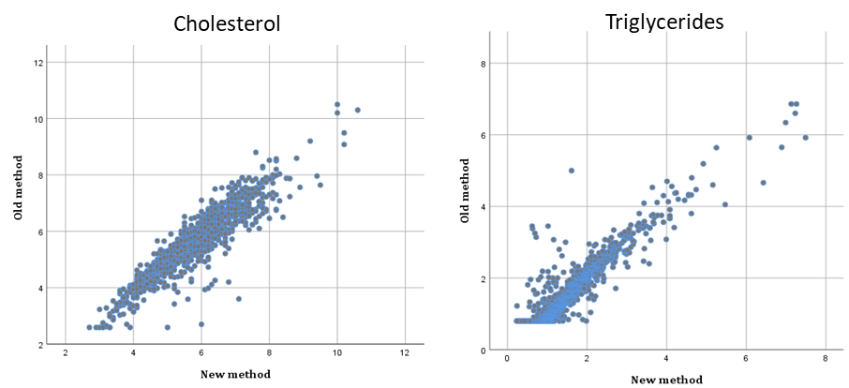**⎯⎯⎯⎯⎯⎯⎯⎯⎯⎯⎯⎯⎯⎯⎯⎯⎯⎯⎯⎯⎯⎯⎯⎯⎯⎯⎯⎯⎯⎯⎯⎯⎯⎯⎯⎯**

*The figures show correlation between the two methods used for blood lipid analyses. The illustrations are based on a data set with 1197 VIP-participants for cholesterol and 837 VIP-participants for triglycerides (old method = reflotron, new method = enzymatic method).*

**Transformation of cholesterol levels between old and new (1999) analysis method in the MONICA survey**

# **Introduction**

The analysis method to determine the total cholesterol levels in blood/plasma has changed between two screenings in the MONICA project. Hence the cholesterol levels obtained at the screening 1999 need to be transformed in order to compare them with previous screenings. For this purpose, 159 of the samples obtained in 1994 were reanalysed using the new analysis method.

# **Statistical methods**

A linear regression model yi=α+βxi+εij, where yi is the cholesterol level with the 1994 (old) method and xi is the level with the 1999 (new) method, was applied. The random error term, εij, is assumed to be independent normally distributed. Furthermore, since there were indications and is reason to believe that the variance increases with higher cholesterol values, the parameters were estimated with weighted least squares, with weight 1/x.

# **Results**

There was one very extreme value. Hence, the analysis was carried out both with that observation included as well as excluded.



*Figure 1. Scatterplot of old vs. new analysis method, the line represent equality.*



*Figure 2. The cholesterol values vs. the rank (ordered number) of cholesterol for the old analysis method.*

## **All observations**

The regression line was estimated to:

cholesterol (old) = 0.051 + 1.004*cholesterol (new)

## **One outlier removed**

The fitted model was:

cholesterol (old) = 0.010 + 1.014*cholesterol (new).

.



*Figure 3. Scatterplot of old vs. new analysis method with fitted regression line (outlier excluded).*



*Figure 4. Residual plot: residuals vs. predicted values.*

# **Conclusions/recommendations**

When comparing cholesterol levels from the two different analysis methods the transformation obtained by excluding one outlier is recommended i.e. cholesterol (old) = 0.010 + 1.014*cholesterol (new). The 1.4% adjustment fits well with the difference between the new and old method observed in Figure 1. Therefore the 1.4% transformation based on linear regression can be justified and this conversion has been done for these subjects.