Sport coaching students at Umeå university act as mentors for young coaches in Swedish sport clubs - based on the mentoring program of Erasmus project Re-Play 2.0

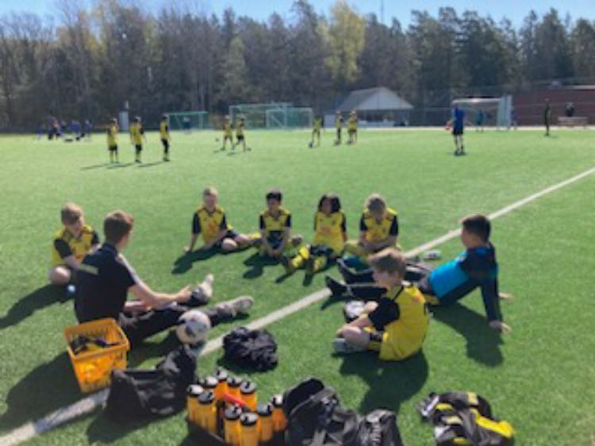

Three times per week at Ösmo GIF, football training sessions take place as part of the Erasmus+ Replay 2.0 project with the Under 11’s. The training sessions are constructed and held by the mentee Elias Viklund, coach of the team, under communication with the mentor Ludvig Stokki, a student in sports coaching programme at Umeå university in Sweden.

The participation in the training sessions looks the same each week. 15 boys from the local area, which is a town about 40 minutes outside of Stockholm - the capital of Sweden. The participants are from different backgrounds, but are equally included in the sessions, which proves the strong connection football can bring.

Ludvig and Elias have shaped the sessions in a way that follows each module from the Replay 2.0 project, one module at a time. The progression worked smoothly, and the players were appreciative of the new methods that were implemented. They adapted very well to the new exercises that dealt with self-esteem, and Elias reported how the players seemed to gain confidence in their abilities during the project.

Elias also reported that he found many advantages from working with the project. He has gained many benefits in terms of planning sessions, giving feedback and making sure feedback is being given in the best possible way.

