Sport coaching students at Umeå university act as mentors for young coaches in Swedish sport clubs - based on the mentoring program of Erasmus project Re-Play 2.0

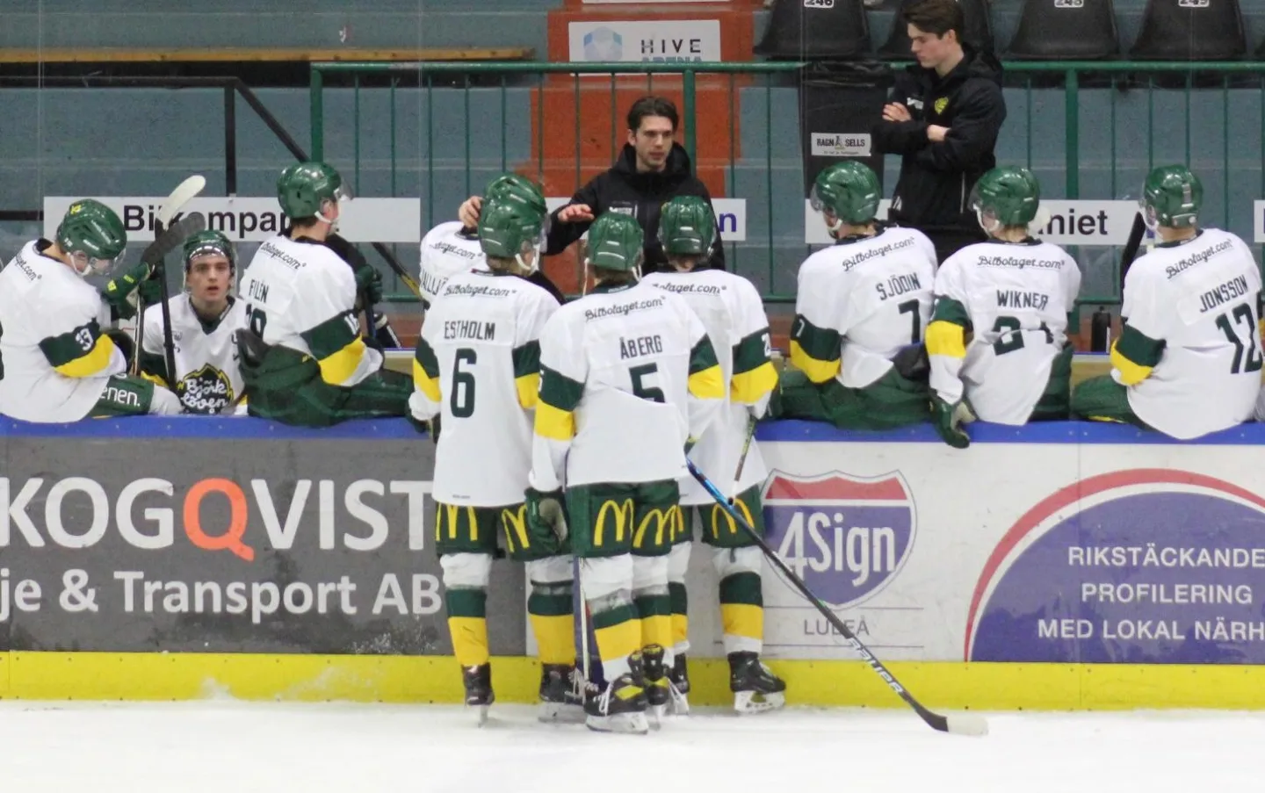
Every Tuesday and Thursday at Winpos Arena, training sessions in ice-hockey take place as a part of the project Re-Play 2.0. The session is with players born in 2007-2009 eg. 13-16 year old and the practices are a part of the players school education as well. The session is held by me, Elias Keuter, a mentor of Re-Play project as well as Head coach for Bjorkloven U20 team and a student in the coaching program at Umeå University. The session is held with my mentee, Patrik Almström.

Every session is with around 20-30 players mostly boys but also a few female players, in the different ages mentioned earlier. Throughout the different sessions during the season different topics from the program have been in focus. The topic has been discussed between the mentor and mentee before and after the session as well as it being implemented in the session. The progress has worked smoothly and developed both the mentee as well as the group of players says mentor Elias Keuter.

The players have worked well together despite the age differences and their relatively young age. They have learned how to be a good teammate, showed leadership qualities when their peers have struggled with a drill, and they have included each other despite their differences. It's been a pleasure to watch the development of both mentee and players.

