Title (Times New Roman 14, bold)
Subtitle (Times New Roman 12, italic)
The extended abstract should include a consistent focus, clear definition of the research framework and methodology, and give a deep understanding of the subject or topic described, including findings, reflections, and conclusions.
Make sure that the text doesn’t include any information referrable to the author. Any information even in the bibliography, image, notes and in the text should be anonymized in this phase to allow the double-blind peer review. Information about the authors will be only included in the platform when registering. Before uploading the text read carefully the Submission Preparation Checklist included in the end of this template. (Please delete this section in the final format).

Style and Conventions
Manuscripts should be submitted online in Microsoft Word Format (.docx). In case of proposals using symbols (e.g., phonetic transcriptions), you are kindly requested to add a PDF version in addition.
The first page will act as the cover. In this page, the authors must present the title, subtitle and the extended abstract in English. All this information may not exceed the length of 1200 words.
The extended abstract will be written in Times New Roman 10, with simple line spacing and indented. Bold or italic can be used, although it is preferable to use italics instead of bold to emphasize. Capitals words will be avoided in both the titles and the text.
The use of hyphens will be preferred to the use of parentheses.
Dates should be in the form of ‘day month year’, e.g., 05 October 2025. When using abbreviations or acronyms, spell them out in full on their first use (except for universally known ones such as UK, USA, UN, etc.). Do not use full points within abbreviations or acronyms.

Language
Only extended abstracts in English will be accepted.

Length
The length of the extended abstracts will be 1200 words, including title, notes and references.

Margins
The margins to be used are the ones of this template: 3 cm upper, 3 cm lower, 3 cm left and 3 cm right; and complete justification.

Paragraph titles
Use the Paragraph titles if needed. Paragraph titles will be written in Times New Roman 10, italic, with capital letters, and they should be aligned to the left, without indentation and with decimal numeration.

Notes
They will be included as footnotes. Written in Times New Roman 8, single line spacing, without indentation and numbered starting at 1. In the body of the text, superscripts will be used to reference the notes.

Enumerations
Authors should use only hyphens, which will be of different sizes if there are several levels.
– First level of enumeration.
- Second level of enumeration.

Bibliography
It will be included at the end of the extended abstracts, written in Times New Roman, size 10, with simple line spacing and without indentation. The references will appear in alphabetical order at the end of the extended abstracts. For all references formats will be used the international standard ISO 690.

Instructions for Bibliographical References:
Specific pages should be used for all the quotation.
Surname of the first author should be written in small caps.
Leave page number in full for both in text-citations and for pages in the works cited (e.g., Nilsson 2000, 115-126). Do not use abbreviated forms, as in 115-26.
Do not use Latin reference tags (op. cit., ibidem, etc.).
Use initialisms to indicate that some information is not available:
– (n.p.) for ‘no publisher’, ‘no place of publication’ or ‘no page’.
– (n.d.) for ‘no date’.
The names of publishers or publishing company names will be as much abbreviated as possible: avoid using ‘Co.’ or ‘Inc.’ and descriptive words (Publishing, etc.). The words ‘university’ and ‘press’ will be abbreviated in any of the corresponding forms: U of Chicago P or Oxford UP.
The full names of authors will be provided.
If any of the author-date cases of citation are not listed here, please check the guide of help for the norm ISO 690 (PDF).

Book with one author.
SURNAME(S), Name. Title of the book (in italics). Edition (if it is not the first edition). City: Publisher, Publication date. ISBN number (if available)
ORTEA VARELA, Enrique. Técnicas de fabricación mecánica. Langreo: Ediciones EO, 2014. ISBN 978-84-943-0311-1
In-text citation (Ortea Varela, 2104)

Book with up to three authors.
SURNAME(S), Name, Name SURNAME, Name SURNAME. Title of the book (in italics). Edition (if it is not the first edition). City: Publisher, Publication date. ISBN number (if available)
MERIAM, James L., L. G. KRAIGE. Mecánica para ingenieros: Dinámica. 3rd edition. Barcelona: Reverté, 2014. ISBN 978-84-291-4409-3
In-text citation (Meriam, Kraige, 2014)

Book with more than three authors.
SURNAME(S), Name and others. Title of the book (in italics). Edition (if it is not the first edition). City: Publisher, Publication date. ISBN number (if available)
BEER, Ferdinand P. and others. Mecánica vectorial para ingenieros: Estática. 10th edition. Mexico: McGraw Hill, 2013. ISBN 978-607-15-0925-3
In-text citation (Beer and others, 2013)

Book chapter
SURNAME(S), Name. Title of the chapter. In: SURNAME(S), Name. Title (in italics). Edition (if it is not the first edition). City: Publisher, Date of publication, inclusive page numbers. Identifier (ISBN number if available)
CORNEJO VEGA, F.J. Estampación. In: ARENILLAS TORREJÓN, J.A. (coord.). Manual de documentación del Patrimonio Mueble. Sevilla: Junta de Andalucía, Consejería de Economía, Innovación, Ciencia y Empleo, 2014, pp. 162-179
In-text citation (Cornejo Vega, 2014)

Journal article
SURNAME(S), Name. Title of the article. In: Title of the journal (in italics). Edition. City: Publisher, Date of publication, Vol., num., inclusive page numbers. Standardised identifier (ISSN, DOI etc., if available)
LÓPEZ JIMÉNEZ, A. El arte en la calle. In: Reis: Revista Española de Investigaciones Sociológicas. 1998, issue 84, pp. 173-194. ISSN 0210-5233
In-text citation (López Jiménez, 1998)
COSTA, C. Lina Bo Bardi y el suburbio. In: Ecología. ARQ. 2019, 103, pp. 90-103. https://doi.org/10.4067/S0717-69962019000300090

Graphics, tables and images
Only one image must be included in the end of the text, width of 15 cm, length of 23,7 cm (see example below). In case you want to include more elements, please compose them in one image.
The image must be numbered below as Fig. 1 (Times New Roman, size 8) and referenced within the text as (Fig. 1). All figures should have brief captions.
Figure should be supplied digitally as one file. Figure can be either .jpg or .tiff files saved at 300 dpi. Line drawings should be submitted as .eps files at 1200 dpi.
Authors are responsible for obtaining permission from copyright holders for reproducing any figures used in their extended abstracts.

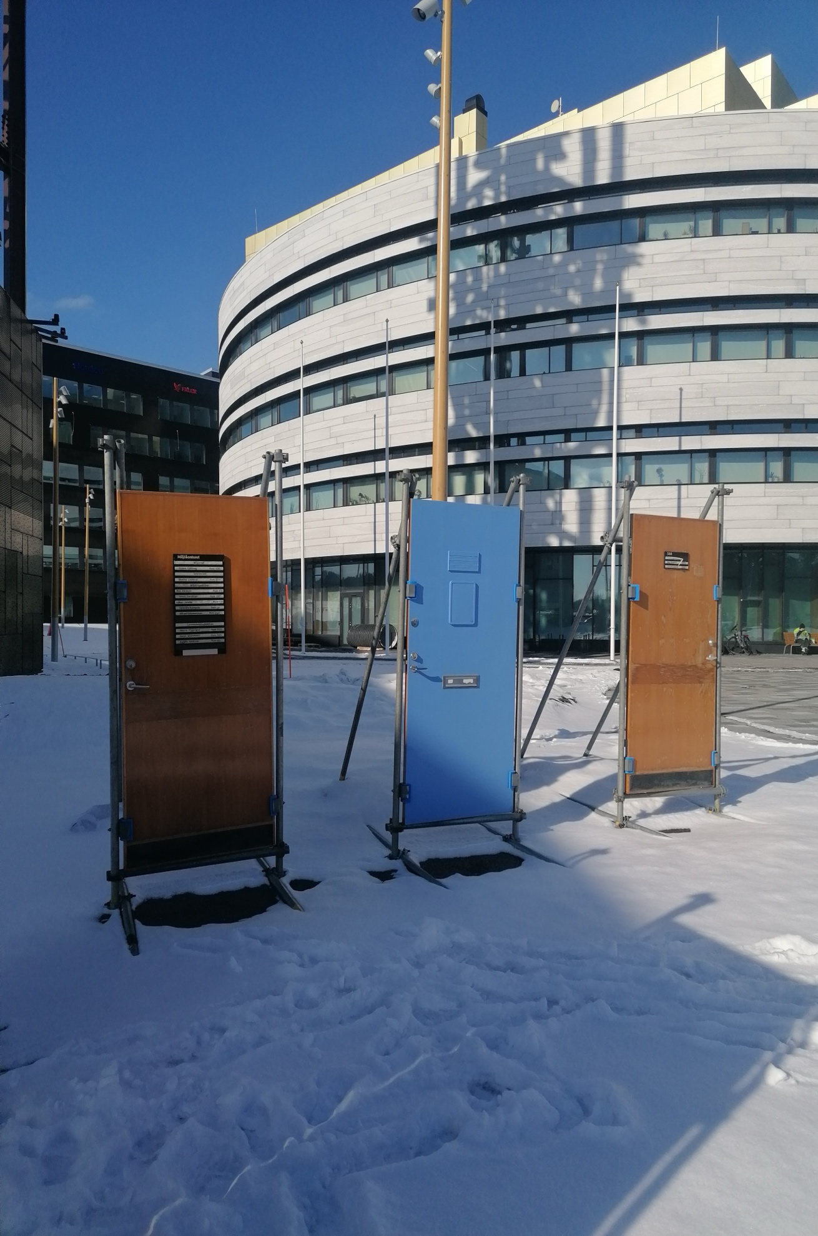
Fig. 1. FOLKMAKT Installation by Jenny Nordmark at the Luleå Biennal 2024 in Kiruna. Ph. M. Luna Nobile 2024.

Submission Preparation Checklist
As part of the submission process, authors are required to check off their submission's compliance with all of the following items, and submissions may be returned to authors that do not adhere to these guidelines.
- Manuscripts have not been published before or are not under consideration for publication elsewhere
- Manuscripts have been fully anonymized: remove full name and affiliation; remove references to funding sources; do not include acknowledgements; remove your name from file name; and make sure that document properties have also been anonymized.
- The manuscripts are written in English.
- All the personal information regarding authorship should be provided when registering on the platform to make a submission: title of the manuscript; authorship (author and EACH of the co-authors); institutional affiliation, full institutional address, including ORCID identifier and e-mail address.
- Authors have obtained permission from copyright holders for reproducing any figures used in their extended abstracts.

Notes, Times New Roman 6, regular

